

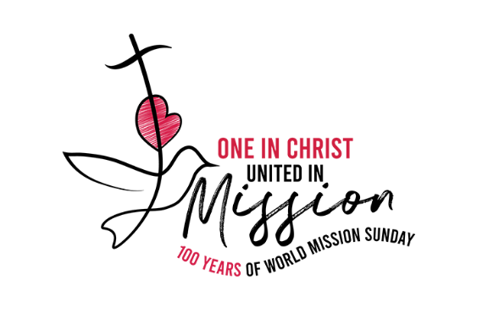

2026 WORLD MISSION LITURGY

PRESIDER: VENUE: TIME:

ONE IN CHRIST
UNITED IN
•





Checklist required for this Liturgy:

✅ Clapping sticks (can be brought up during Acknowledgement of Country)

✅ Coloured fabric (Malawi flag colours: green, red, & black) to be draped over boxes for a sacred space with book holders to support framed or laminated image/s.
✅ Image of St Matthew’s Church in Malawi: To be brought up during ‘Introducing Malawi’.
✅ Basket of Maize (Corn): To be brought up during ‘Introducing Malawi’.

✅ Container of dry dirt/soil: To be brought up during ‘Introducing Malawi’.
✅ Exercise Book: To be brought up during ‘Introducing Malawi’.

✅ Photo of Malawi landscape (can be placed in sacred space)

✅ Malawi Flag or image of flag: To be brought up during ‘Introducing Malawi’.

✅ A clear container of water: To be brought up during ‘Introducing Malawi’.

✅ School candles or banners

✅ Candle/s and lighter/match

✅ Catholic Mission video (Can be played at one of two times - as stated in Liturgy or toward the end - your choosing).

✅ Catholic Mission PowerPoint resource

✅ Computer

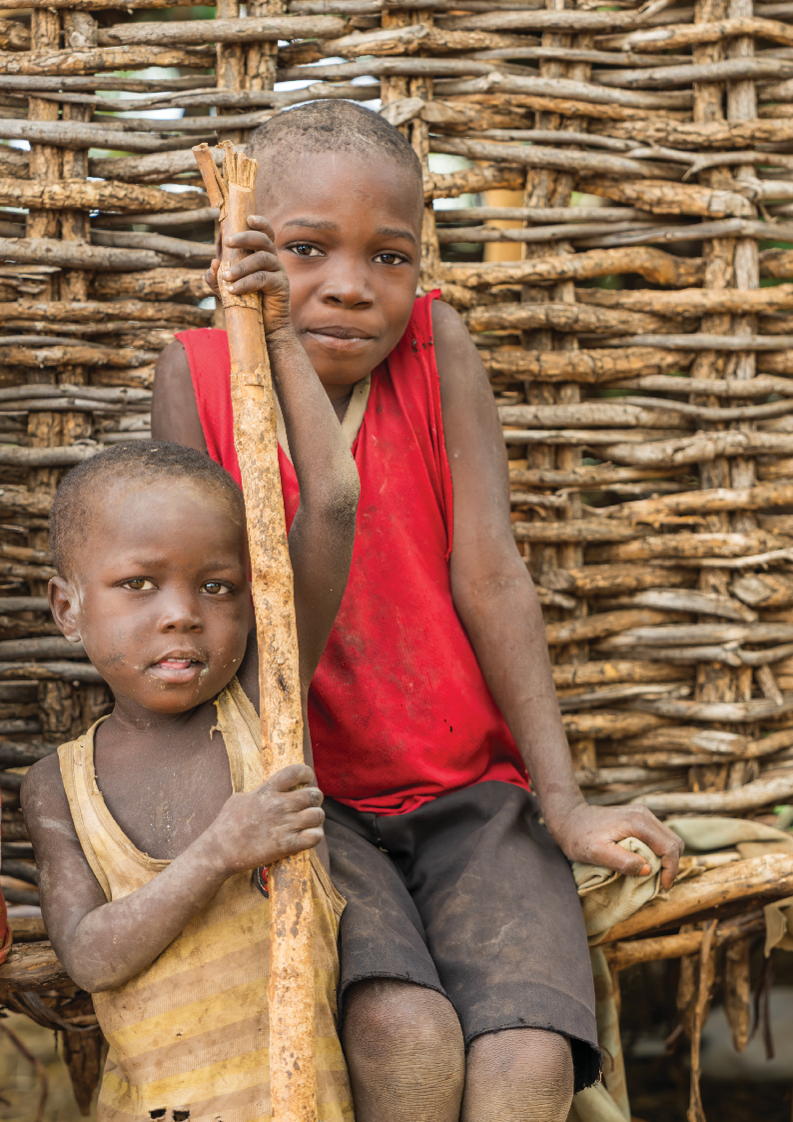

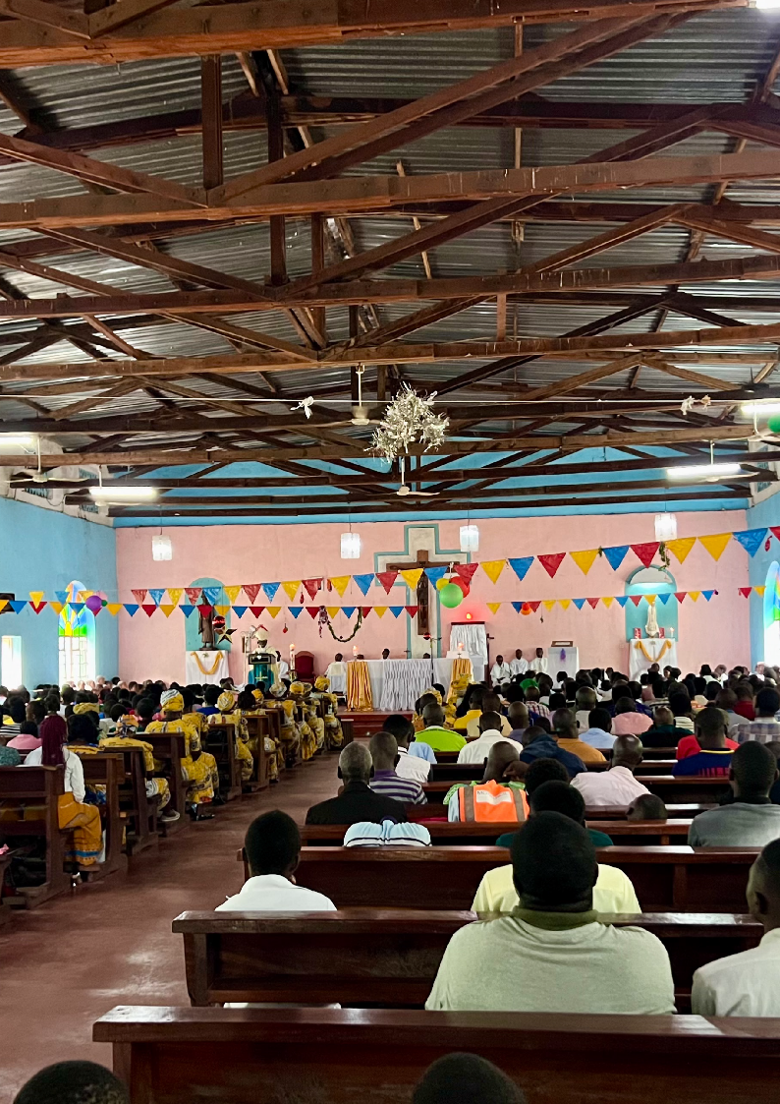



One in Christ United in Mission
INTRODUCTION

Reflection
For us today, the theme for this year's World Mission Day is "One in Christ, United in Mission". This reminds us that we are all connected through God's love. No matter where we live, what language we speak, or what challenges we face, we are part of one global family in Christ. As followers of Jesus, we are called not only to care for one another but also to share His love through our words and actions.

This year, as we learn about the people of Malawi, we see what it means to live this mission every day.
Known as the Warm Heart of Africa, Malawi is a country rich in faith, culture, and community spirit. Yet many families face challenges such as poverty, food insecurity, limited access to education, and the effects of natural disasters. Despite these difficulties, the people of Malawi continue to show remarkable resilience, hope, and trust in God.

Their story reminds us that mission is not about helping people from a distance; it is about recognising that we are one body in Christ. When one part of the body suffers, we all feel it. When one part rejoices, we all celebrate together. Through prayer, solidarity, learning, and action, we walk alongside our brothers and sisters in Malawi as members of the same family of faith.

As we reflect today, may we remember that mission begins with each of us. Through simple acts of kindness, generosity, and love, we become living witnesses of Christ's presence in the world. Together, united in faith and purpose, we can bring hope and help create a brighter future for all.

World Mission Liturgy 2026

One in Christ United in Mission

Acknowledgement of Country
We respectfully acknowledge the Traditional Custodians of the land on
which we gather today, the people, and pay our respects to
Elders past and present. We give thanks for the land, waterways, plants, animals, and skies that have cared for people here for many thousands of years. We extend that respect to all Aboriginal and Torres Strait Islander peoples with us today.
Introducing Malawi

Student:

Student:
The wisdom and love of God are beyond our imagination. God's goodness is a gift we treasure. Through God's Spirit, God continually opens our hearts and minds to new ways of connecting with one another, sharing our stories, and recognising our place in God's global family. Today, we carry in our hearts the stories, hopes, and people of Malawi.

Welcome to our liturgy for World Mission Month 2026. This year, as we celebrate the centenary of World Mission Sunday, we gather around the theme "One in Christ, United in Mission."

Today we celebrate the people of Malawi, honouring the unique gifts they share with the world. May this celebration inspire us to recognise that we are truly one in Christ, united in mission, bringing hope to our world through our prayers, actions, and care for one another.
Let us create our sacred space.
We will now create our space for today’s liturgy, centred on Malawi. As we bring forward each item, we invite you to reflect on the faith, culture, and daily life of the people of Malawi.
Through their stories, symbols, and strength, we are reminded of how God’s love is lived out across the world - especially in places that may seem far from our own.
Each item placed in the space represents a part of Malawi’s spirit - its faith, its people, its land, and its hope.



GATHERING
World Mission Liturgy 2026

One in Christ United in Mission

Student:

Student:

Student:
We bring forward a picture of St Matthew’s located in the Chikwawa Diocese. It is a special church and serves as a sign of hope throughout the region. Here, many people come together to pray and it is filled with love and joy. This reminds us that God is with us everywhere - even in faraway or quiet places.
The image is placed in the sacred space.

We bring forward a basket of maize (we might know it as corn here in Australia) - a gift from the earth. In the Diocese of Chikwawa, maize is a food that comes from working
closely with the land and with one another. It reminds us to always praise God for all of creation as God calls us to live with gratitude, simplicity, and care for our common home.
The maize is placed in the sacred space.

We bring forward this exercise book, a simple but powerful symbol that every child deserves the opportunity to learn. For many children in Malawi, going to school is not easy. Long distances, poverty, and a lack of classrooms can make education difficult to access. This exercise book reminds us that learning brings hope, opens doors to the future, and helps children discover the gifts God has given them.
The book is placed in the sacred space.

Student:
We bring forward this bowl of earth, representing the land on which families and communities in Malawi live, work, and grow. The earth provides food, supports livelihoods, and is a precious gift from God. Yet this same land is vulnerable. Severe droughts can leave the soil dry and cracked, while floods and cyclones can wash away crops, homes, and precious topsoil in a matter of hours, making life incredibly difficult for many families. This bowl of earth reminds us of both the beauty and the fragility of creation.
The bowl is placed in the sacred space.


GATHERING

World Mission Liturgy 2026

One in Christ United in Mission

Student:

Student:

Student:

Student:

Student:
We bring forward this bowl of water, reminding us that every person deserves the dignity of clean, safe water. In Malawi, many families and children walk long distances each day to collect water for drinking, cooking, and washing. Water is God's gift of life, bringing health, hope, and the opportunity to flourish. As we place this bowl in our sacred space, may it remind us to give thanks for the blessings we often take for granted, to care for God's creation, and to pray for all those who continue to face the daily challenge of accessing this precious gift.
The bowl of water is placed in the sacred space.

We bring forward the flag of Malawi. Its black stripe represents the people of Malawi, the red symbolises the sacrifices made for the nation's freedom, and the green reflects the country's rich natural beauty and fertile land. The rising red sun represents the dawn of hope, freedom, and the promise of a bright future for the people of Malawi.
The flag is placed in the sacred space.

Students are now invited to place their school candles or banners around the sacred space. The candle reflects the light of Christ, present in all cultures and communities – we are “One in Christ, united in Mission”.
Candles and banners are placed in the space.

May we open our hearts to learn more about the missionary work of the Church in Malawi, drawing inspiration from the remarkable creativity, resilience, and hope of the Malawi people. As we stand in solidarity with them in both their joys and their struggles. Let us take a moment to reflect.
We now invite you to stand for our gathering song.


GATHERING

World Mission Liturgy 2026

One in Christ United in Mission

INTRODUCTORY RITES
Gathering Song. Please stand.

Suggested for Primary Schools: Lead Me, Lord - John D Becker Suggested for High Schools: A Rightful Place - Steve Angrisano
[Please find the songs’ resource files on ONELICENSE. Find the relevant links on our webpage.]

Welcome Presider:

All:

Presider:

All:
Presider: All:
Presider: All:
Presider: All:

We gather ... In the name of the Father, and of the Son, and of the Holy Spirit.
Amen
Slight pause before proceeding.

Lord Jesus, you walk with all of creation, especially those at the margins who are in need. Lord, have mercy.
Lord, have mercy.
You lift up people who are poor and forgotten. Christ, have mercy.
Christ, have mercy.
You call us to be bearers of hope. Lord, have mercy.
Lord, have mercy.
May our loving God, who is rich in mercy, forgive us, renew our hearts, and lead us to everlasting peace.
Amen.



INTRODUCTORY RITES

World Mission Liturgy 2026

One in Christ United in Mission

Opening Prayer

Presider:

All:
Let us pray.
God of every nation, You call us to be One in Christ and United in Mission, walking together as one family in faith, hope, and love.
Bless the people of Malawi, whose stories of resilience, faith, and community inspire us to listen deeply, care generously, and stand in solidarity with one another.

Amen

Please be seated.

LITURGY OF THE WORD
First Reading Isaiah 32:15-18

Student:

All:
A reading from the prophet Isaiah. The effect of justice will be peace. Once more there will be poured on us the spirit from above;
then shall the wilderness be fertile land; and fertile land become forest.
In the wilderness justice will come to live and integrity in the fertile land;
integrity will bring peace, justice give lasting security.
My people will live in a peaceful home, in safe houses, in quiet dwellings.
The Word of the Lord
Thanks be to God.

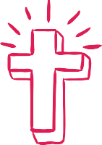
Pause in silence for personal reflection on the reading.
INTRODUCTORY RITES

World Mission Liturgy 2026

One in Christ United in Mission

Responsorial Psalm Ps 71:2-4, 7-8, 12-13, 17

Reader:
Response: Reader:
Justice shall flourish in God's time, and fullness of peace for ever.

Justice shall flourish in God's time, and fullness of peace for ever.

May the mountains bring forth peace for the people and the hills, justice. May God defend the poor of the people and save the children of the needy.

Response: Reader:
Response: Reader:
Response: Reader:
Justice shall flourish in God's time, and fullness of peace for ever.

In God's days justice shall flourish and peace till the moon fails.
God shall rule from sea to sea, from the Great River to earth's bounds. Justice shall flourish in God's time, and fullness of peace for ever.
For God shall save the poor when they cry and the needy who are helpless. God will have pity on the weak and save the lives of the poor.
Justice shall flourish in God's time, and fullness of peace for ever.
May God's name be blessed for ever and endure like the sun.
Every tribe shall be blessed in God, all nations bless God's name.

Response:
Justice shall flourish in God's time, and fullness of peace for ever.



LITURGY OF THE WORD
Pause in silence for personal reflection.

World Mission Liturgy 2026

One in Christ United in Mission
Gospel

Gospel Acclamation Please stand
Halle, Halle, Halle - Marty Haugen
[Please find the song’s resource files on GIA Music. Find the relevant links on our webpage.]
Gospel Matthew 5:1–12

Presider: ALL:
Presider: ALL:
Presider:

ALL:
Homily
The Lord be with you. And with your Spirit.
A reading from the Gospel according to Matthew Glory to you O Lord
When Jesus saw the crowds, he went up the mountain; and after he sat down, his disciples came to him.
Then he began to speak, and taught them, saying:
“Blessed are the poor in spirit, for theirs is the kingdom of heaven. Blessed are those who mourn, for they will be comforted.
Blessed are the meek, for they will inherit the earth.
Blessed are those who hunger and thirst for righteousness, for they will be filled.
Blessed are the merciful, for they will receive mercy. Blessed are the pure in heart, for they will see God.
Blessed are the peacemakers, for they will be called children of God.
Blessed are those who are persecuted for righteousness’ sake, for theirs is the kingdom of heaven.
Blessed are you when people revile you and persecute you and utter all kinds of evil against you falsely on my account.
Rejoice and be glad, for your reward is great in heaven, for in the same way they persecuted the prophets who were before you.”

The Gospel of the Lord
Praise to you, Lord Jesus Christ




One in Christ United in Mission

Student Reflection of Gospel

Student:
In today's Gospel, Jesus teaches us what it really means to live a good and meaningful life. The world often tells us that success comes from being popular, powerful, wealthy, or always getting our own way. But Jesus turns those ideas upside down.
Jesus says that those who are kind, humble, merciful, peaceful, and willing to stand up for what is right are truly blessed. He reminds us that God's Kingdom is built not on power, but on love.
As we reflect on the lives of people in Malawi and on our theme, "One in Christ, United in Mission," we are invited to see that we are all part of one global family. Even when people face challenges, hardship, or injustice, they can still be signs of hope, courage, and faith.
Jesus calls each of us to be peacemakers in our classrooms, our families, and our communities. He asks us to show mercy to those who are hurting, kindness to those who feel left out, and courage when we see something unfair.
Today, let us ask ourselves:
- How can I be a peacemaker this week?
- How can I show kindness and mercy to others?
- How can I use my gifts to bring hope to someone in need?
May we leave this liturgy inspired to follow Jesus' example, united as one family in Christ, and ready to share God's love with all people.
Mission begins with small acts of love, and every one of us can make a difference.

Student Reflection

World Mission Liturgy 2026

One in Christ United in Mission
Prayers of intercession Please be seated.

Presider: Student:

All: Student:

All: Student:

All: Student:

All: Student:

All: Student:

All:
Let us pray for the Church and for the world with hearts full of hope.
For the Church in Malawi, that it may continue to be a light of hope and unity.
Lord hear us.
Lord, hear our prayer.
We pray for leaders around the world, that they govern with justice and mercy.
Lord hear us.
Lord, hear our prayer.
We pray for the people of Malawi, especially those in rural communities without food or water. May we respond in love.
Lord hear us.
Lord, hear our prayer.
We pray for all who work in mission - especially those walking alongside children and families in Malawi.
Lord hear us.
Lord, hear our prayer.
We pray for each of us, that we live simply, love deeply, and walk humbly with God, one in Christ, united in mission.
Lord hear us.
Lord, hear our prayer.
Loving and Merciful God,
As we go forth from this gathering, fill our hearts with your peace and compassion. Open our eyes to see those who suffer injustice and strengthen us to stand in solidarity with our sisters and brothers throughout the world. May we walk in the footsteps of Christ, united in mission, building your Kingdom through acts of kindness, mercy, and hope. We ask this through Christ our Lord.
Amen.

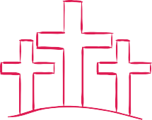

World Mission Liturgy 2026
Prayers of intercession

One in Christ United in Mission

The Our Father

Presider:
Please stand and join us in saying the prayer Jesus has taught us.

All:
Our Father, who art in heaven, hallowed be thy name;
thy kingdom come
thy will be done on earth as it is in heaven. Give us this day our daily bread,
and forgive us our trespasses,
as we forgive those who trespass against us; and lead us not into temptation
but deliver us from evil. Amen



LITURGY

World Mission Liturgy 2026

One in Christ United in Mission

Greeting
Please stand.

Presider:
O God, you send us out as messengers of joy, peace, and justice. May your Spirit guide our every step.
As missionaries of hope, may we lift others up, care for creation, and bring your love to the world.
May almighty God bless you, the Father, and the Son, and the Holy Spirit. Let us go in peace to love and serve God and one another.

All:
Amen


CONCLUDING RITE

Recessional song:
Suggested for Primary Schools: Hearts on Fire - Michael Mangan Suggested for High Schools: Go out, Go Out - Curtis Stephan

Acknowledgements

Reading and Gospel from New Revised Standard Version Bible: Catholic Edition, copyright © 1989, 1993 the Division of Christian Education of the National Council of the Churches of Christ in the United States of America. All rights reserved.

Text Excerpts from the English translation of The Roman Missal © 2010, International Commission on English in the Liturgy Corporation. All rights reserved.

Images and Symbols:

P.1: Photograph by Simone Medri. © Catholic Mission 2025 P.2: Photograph by Simone Medri. © Catholic Mission 2025 P.3: Photograph by Simone Medri. © Catholic Mission 2025 P.4: FOTW Flags Of The World website

World Mission Liturgy 2026

