

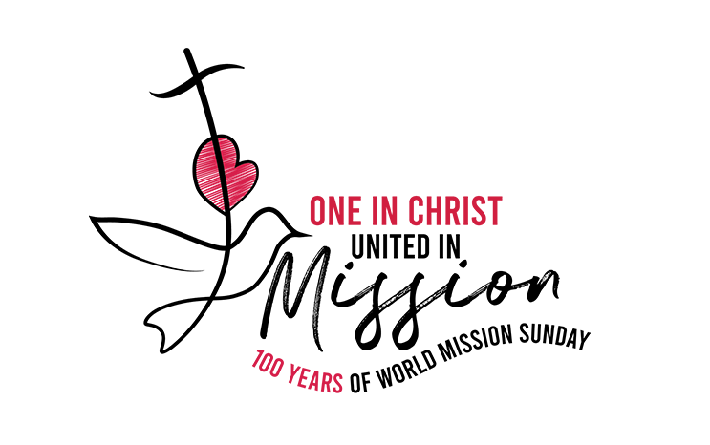

2026 WORLD MISSION MASS

PRESIDER: VENUE: TIME:

ONE IN CHRIST
UNITED IN
•
•

100 YEAR

Checklist required for this Mass:

✅ Clapping sticks (can be brought up during Acknowledgement of Country)

✅ Coloured fabric (Malawi flag colours: green, red, & black) to be draped over boxes for a sacred space with book holders to support framed or laminated image/s.
✅ Image of St Matthew’s Church in Malawi: To be brought up during ‘Introducing Malawi’.
✅ Basket of Maize (Corn): To be brought up during ‘Introducing Malawi’.

✅ Container of dry dirt/soil: To be brought up during ‘Introducing Malawi’.
✅ Exercise Book: To be brought up during ‘Introducing Malawi’.

✅ Photo of Malawi landscape (can be placed in sacred space)

✅ Malawi Flag or image of flag: To be brought up during ‘Introducing Malawi’.

✅ A clear container of water: To be brought up during ‘Introducing Malawi’.

✅ School candles or banners

✅ Candle/s and lighter/match

✅ Catholic Mission video (Can be played at one of two times - as stated in Liturgy or toward the end - your choosing).

✅ Catholic Mission PowerPoint resource

✅ Computer

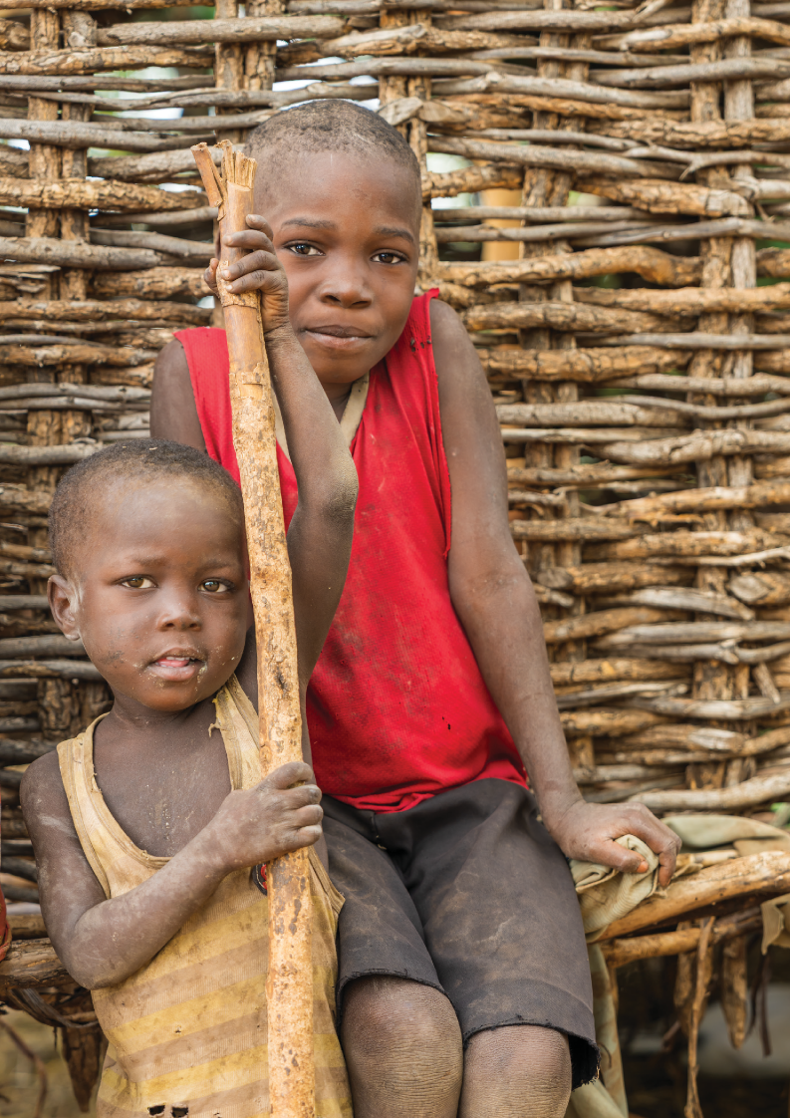

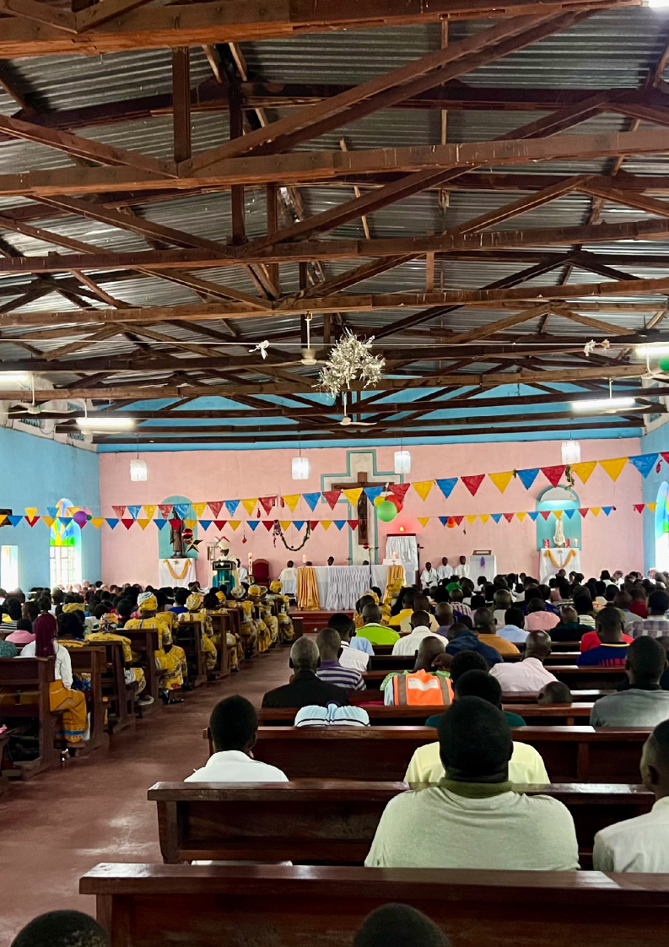

World Mission Mass 2026



One in Christ United in Mission








INTRODUCTION

Reflection
For us today, the theme for this year's World Mission month is "One in Christ, United in Mission". This reminds us that we are all connected through God's love. No matter where we live, what language we speak, or what challenges we face, we are part of one global family in Christ. As followers of Jesus, we are called not only to care for one another but also to share His love through our words and actions.

This year, as we learn about the people of Malawi, we see what it means to live this mission every day.
Known as the Warm Heart of Africa, Malawi is a country rich in faith, culture, and community spirit. Yet many families face challenges such as poverty, food insecurity, limited access to education, and the effects of natural disasters. Despite these difficulties, the people of Malawi continue to show remarkable resilience, hope, and trust in God.

Their story reminds us that mission is not about helping people from a distance; it is about recognising that we are one body in Christ. When one part of the body suffers, we all feel it. When one part rejoices, we all celebrate together. Through prayer, solidarity, learning, and action, we walk alongside our brothers and sisters in Malawi as members of the same family of faith.

As we reflect today, may we remember that mission begins with each of us. Through simple acts of kindness, generosity, and love, we become living witnesses of Christ's presence in the world. Together, united in faith and purpose, we can bring hope and help create a bright futures.

World Mission Mass 2026


One in Christ United in Mission
Acknowledgement of Country








GATHERING
We respectfully acknowledge the Traditional Custodians of the land on
which we gather today, the people, and pay our respects to
Elders past and present. We give thanks for the land, waterways, plants, animals, and skies that have cared for people here for many thousands of years. We extend that respect to all Aboriginal and Torres Strait Islander peoples with us today
Introducing Malawi

Student:

The wisdom and love of God are beyond our imagination. God's goodness is a gift we treasure. Through God's Spirit, He continually opens our hearts and minds to new ways of connecting with one another, sharing our stories, and recognising our place in God's global family. Today, we carry in our hearts the stories, hopes, and people of Malawi.

Welcome to our liturgy for World Mission Month 2026. This year, as we celebrate the centenary of World Mission Sunday, we gather around the theme "One in Christ, United in Mission."

Today we celebrate the people of Malawi, honouring the unique gifts they share with the world. May this celebration inspire us to recognise that we are truly one in Christ, united in mission, bringing hope to our world through our prayers, actions, and care for one another.
Let us create our sacred space.
We will now create our space for today’s liturgy, centred on Malawi. As we bring forward each item, we invite you to reflect on the faith, culture, and daily life of the people of Malawi.
Through their stories, symbols, and strength, we are reminded of how God’s love is lived out across the world - especially in places that may seem far from our own.
Each item placed in the space represents a part of Malawi’s spirit - its people, its land, and its hope.

World Mission Mass 2026

One in Christ United in Mission



GATHERING

Student:

Student:

Student:
We bring forward a picture of St Matthew’s located in the Chikwawa diocese. It is a special church and serves as a sign of hope throughout the region. Here, many people come together to pray and it is filled with love and joy. This reminds us that God is with us everywhere - even in faraway or quiet places.
The image is placed in the sacred space.

We bring forward a basket of maize (we might know it as corn here in Australia) - a gift from the earth. In the Diocese of Chikwawa, maize is a food that comes from working
closely with the land and with one another. It reminds us to always praise God for all of creation as God calls us to live with gratitude, simplicity, and care for our common home.
The maize is placed in the sacred space.

We bring forward this exercise book, a simple but powerful symbol that every child deserves the opportunity to learn. For many children in Malawi, going to school is not easy. Long distances, poverty, and a lack of classrooms can make education difficult to access. This exercise book reminds us that learning brings hope, opens doors to the future, and helps children discover the gifts God has given them.
The book is placed in the sacred space.

Student:
We bring forward this bowl of earth, representing the land on which families and communities in Malawi live, work, and grow. The earth provides food, supports livelihoods, and is a precious gift from God. Yet this same land is vulnerable. Severe droughts can leave the soil dry and cracked, while floods and cyclones can wash away crops, homes, and precious topsoil in a matter of hours, making life incredibly difficult for many families. This bowl of earth reminds us of both the beauty and the fragility of creation.
The bowl is placed in the sacred space.

World Mission Mass 2026

One in Christ United in Mission



GATHERING

Student:

Student:

Student:

Student:

Student:
We bring forward this bowl of water, reminding us that every person deserves the dignity of clean, safe water. In Malawi, many families and children walk long distances each day to collect water for drinking, cooking, and washing. Water is God's gift of life, bringing health, hope, and the opportunity to flourish. As we place this bowl in our sacred space, may it remind us to give thanks for the blessings we often take for granted, to care for God's creation, and to pray for all those who continue to face the daily challenge of accessing this precious gift.
The bowl of water is placed in the sacred space.

We bring forward the flag of Malawi. Its black stripe represents the people of Malawi, the red symbolises the sacrifices made for the nation's freedom, and the green reflects the country's rich natural beauty and fertile land. The rising red sun represents the dawn of hope, freedom, and the promise of a bright future for the people of Malawi.
The flag is placed in the sacred space.

Students are now invited to place their school candles or banners around the sacred space. The candle reflects the light of Christ, present in all cultures and communities – we are “One in Christ, united in Mission”.
Candles and banners are placed in the space.

May we open our hearts to learn more about the missionary work of the Church in Malawi, drawing inspiration from the remarkable creativity, resilience, and hope of the Malawi people. As we stand in solidarity with them in both their joys and their struggles. Let us take a moment to reflect.
We now invite you to stand for our gathering song.

World Mission Mass 2026

One in Christ United in Mission




INTRODUCTORY RITES

Introductory Rites
Gathering Song. Please stand.

Suggested for Primary Schools: Lead Me, Lord - John D Becker Suggested for High Schools: A Rightful Place - Steve Angrisano
[Please find the songs’ resource files on ONELICENSE. Find the relevant links on our webpage.]

Welcome Presider:
All:

Presider:

All:
Presider: All:
Presider: All:
Presider:
All:

We gather ... In the name of the Father, and of the Son, and of the Holy Spirit.
Amen
Slight pause before proceeding.

Lord Jesus, you walk with all of creation, especially those at the margins who are in need. Lord, have mercy.
Lord, have mercy.
You lift up people who are poor and forgotten. Christ, have mercy.
Christ, have mercy.
You call us to be bearers of hope. Lord, have mercy. Lord, have mercy.
May our loving God, who is rich in mercy, forgive us, renew our hearts, and lead us to everlasting peace.
Amen.

World Mission Mass 2026

One in Christ United in Mission


INTRODUCTORY RITES
Opening Prayer

Presider:

All:
Let us pray.
God of every nation, You call us to be One in Christ and United in Mission, walking together as one family in faith, hope, and love.
Bless the people of Malawi, whose stories of resilience, faith, and community inspire us to listen deeply, care generously, and stand in solidarity with one another.

Amen

Please be seated.

Liturgy of the Word
First Reading Isaiah 32:15-18

Student:

All:
A reading from the prophet Isaiah.

The effect of justice will be peace. Once more there will be poured on us the spirit from above;
then shall the wilderness be fertile land; and fertile land become forest.
In the wilderness justice will come to live and integrity in the fertile land;
integrity will bring peace, justice give lasting security.
My people will live in a peaceful home, in safe houses, in quiet dwellings.
The Word of the Lord.
Thanks be to God.

Pause in silence for personal reflection on the reading.

World Mission Mass 2026

One in Christ United in Mission




LITURGY OF THE WORD

Responsorial Psalm Ps 71:2-4, 7-8, 12-13, 17

Reader:
Response: Reader:
Justice shall flourish in God's time, and fullness of peace for ever.

Justice shall flourish in God's time, and fullness of peace for ever.

May the mountains bring forth peace for the people and the hills, justice. May God defend the poor of the people and save the children of the needy.

Response: Reader:
Response: Reader:
Response: Reader:
Justice shall flourish in God's time, and fullness of peace for ever.

In God's days justice shall flourish and peace till the moon fails.
God shall rule from sea to sea, from the Great River to earth's bounds. Justice shall flourish in God's time, and fullness of peace for ever.
For God shall save the poor when they cry and the needy who are helpless. God will have pity on the weak and save the lives of the poor.
Justice shall flourish in God's time, and fullness of peace for ever.
May God's name be blessed for ever and endure like the sun.
Every tribe shall be blessed in him, all nations bless God's name.

Response:
Justice shall flourish in God's time, and fullness of peace for ever.

Pause in silence for personal reflection.

World Mission Mass 2026

One in Christ United in Mission



Gospel

Gospel Acclamation Please stand
Halle, Halle, Halle - Marty Haugen
[Please find the song’s resource files on GIA Music. Find the relevant links on our webpage.]
Gospel Matthew 5:1–12

Presider: All:
Presider:
All:
Presider:

ALL:
Homily
The Lord be with you.
And with your Spirit.
A reading from the Gospel according to Matthew
Glory to you O Lord
When Jesus saw the crowds, he went up the mountain; and after he sat down, his disciples came to him.
Then he began to speak, and taught them, saying:
“Blessed are the poor in spirit, for theirs is the kingdom of heaven. Blessed are those who mourn, for they will be comforted.
Blessed are the meek, for they will inherit the earth.
Blessed are those who hunger and thirst for righteousness, for they will be filled.
Blessed are the merciful, for they will receive mercy. Blessed are the pure in heart, for they will see God.
Blessed are the peacemakers, for they will be called children of God.
Blessed are those who are persecuted for righteousness’ sake, for theirs is the kingdom of heaven.
Blessed are you when people revile you and persecute you and utter all kinds of evil against you falsely on my account.
Rejoice and be glad, for your reward is great in heaven, for in the same way they persecuted the prophets who were before you.”

The Gospel of the Lord
Praise to you, Lord Jesus Christ.

World Mission Mass 2026

One in Christ United in Mission




Prayers of intercession

Prayers of Intercession Please be seated.

Presider: Student:

All: Student:

All:
Student:

All: Student:

All: Student:

All: Student:

All:
We now place our petition to our gracious God.
We pray for our Church... may she continue to be a light of hope and unity.
Lord hear us.
Lord, hear our prayer.
We pray for leaders around the world, that they govern with justice and mercy.
Lord hear us.
Lord, hear our prayer.
We pray for the people of Malawi, especially those in rural communities without food or water. May we respond in love.
Lord hear us.
Lord, hear our prayer.
We pray for all who work in mission - especially those walking alongside children and families in Malawi.
Lord hear us.
Lord, hear our prayer.
We pray for each of us, that we live simply, love deeply, and walk humbly with God, one in Christ, united in mission.
Lord hear us.
Lord, hear our prayer.
Loving and Merciful God,
As we go forth from this gathering, fill our hearts with your peace and compassion. Open our eyes to see those who suffer injustice and strengthen us to stand in solidarity with our sisters and brothers throughout the world. May we walk in the footsteps of Christ, united in mission, building your Kingdom through acts of kindness, mercy, and hope. We ask this through Christ our Lord.
Amen.

World Mission Mass 2026

One in Christ United in Mission




LITURGY

Liturgy of the Eucharist Please remain seated.
The gifts and bread and wine are brought forward.
Suggested song: Table Song - Kevin Bates
[Please find the music resource files on ONELICENSE. Find the relevant links on our webpage.]

Presider:

All:
Blessed are you, Lord God of all creation, for through your goodness we have received the bread we offer you: fruit of the earth and work of human hands, it will become for us the bread of life.
Blessed be God forever

The Presider then places the paten with the bread on the corporal. The wine and a little water are poured into the chalice, saying quietly:

Presider:
By the mystery of this water and wine may we come to share in the divinity of Christ who humbled himself to share in our humanity.

Taking the chalice and holding it slightly above the altar, Presider says inaudibly:

Presider:
Blessed are you, Lord God of all creation, for through your goodness

we have received the wine we offer you: fruit of the vine and work of

All:
human hands, it will become our spiritual drink.
Blessed be God forever

Then the Presider places the chalice on the corporal. The Presider bows and says inaudibly:

Presider:
With humble spirit and contrite heart may we be accepted by you, O Lord, and may our sacrifice in your sight this day be pleasing to you, Lord God.

The Presider washes his hands, saying inaudibly:

Presider:
Wash me, O Lord, from my iniquity and cleanse me from my sin.

World Mission Mass 2026

One in Christ United in Mission



CONCLUDING RITE

Prayer over the Offerings
Please stand.

Presider: All:
Pray, my brothers and sisters, that my sacrifice and yours may be acceptable to God, the almighty Father.
May the Lord accept the sacrifice at your hands for the praise and glory of his name, for our good and the good of all his holy Church.

Presider:
Loving Creator look upon the face of your Church, so that through him, from the rising of the sun to its setting, your name may be exalted among the nations, and in every place a single offering may be presented to you. Through Christ our Lord.

All:
Amen

World Mission Mass 2026

One in Christ United in Mission
Eucharistic Prayer for Children



Gospel

Presider: All:
Presider: All:
Presider: All:
The Lord be with you.
And with your Spirit.
Lift up your hearts.
We lift them up to the Lord.
Let us give thanks to the Lord our God.
It is right and just. (Clap three times)

The Presider, with hands extended, continues the Preface.

Presider:
God our Father, you have brought us here together so that we can give you thanks and praise for all the wonderful things you have done. We thank you for all that is beautiful in the world and for the happiness you have given us. We praise you for daylight and for your word which lights up our minds. We praise you for the earth, and all the people who live on it, and for our life which comes from you. We know that you are good. You love us and do great things for us.

The Presider with hands extended, says:

Presider:
Loving God, you are always thinking about your people; you never forget us. You sent us your Son Jesus who gave his life for us and who came to save us. He cured sick people; He cared for those who were poor and wept for those who were sad. He forgave sinners and taught us to forgive each other. He loved everyone and showed us how to be kind. He took children in his arms and blessed them.

The Presider, with hands extended, continues:

Presider:
Creator God, all over the world your people praise you.
So now we pray with the whole Church: with Leo our Pope and me, your unworthy servant. In heaven the blessed Virgin Mary, the Apostles and all the Saints always sing your praise. Now we join with them and with the Angels to adore you as we sing:

World Mission Mass 2026

One in Christ United in Mission



Gospel

Eucharistic Prayer for Children

All:
Holy, Holy, Holy Lord, God of hosts. Heaven and earth are full, full of your glory. Hosanna in the highest. Blessed is he who comes in the name of the Lord Hosanna in the highest.

The Presider, with hands extended, continues:

Presider:
God our Father, you are most holy, and we want to show you that we are grateful. We bring you bread and wine

The Presider joins his hands and, holding them extended over the offerings, says:

Presider:
And ask you to send your Holy Spirit to make these gifts

He joins hands and makes the Sign of the Cross once over the bread and chalice together, saying:

Presider:
The body and blood of Jesus your Son.

The Presider joins his hands.

Presider:
Then we can offer to you what you have given for us. On the night before he died, Jesus was having supper with his Apostles.

The Presider takes the bread and, holding it slightly raised above the altar, continues:

Presider:
He took bread from the table.
He gave you thanks and praise.
Then he broke the bread, gave it to his friends and said:

He bows slightly.

Presider:
Take this, all of you and eat of it: for this is my body
which will be given up for you.

The Presider shows the consecrated host to the people, places it again on the paten, and genuflects in adoration.

After this, he continues:

World Mission Mass 2026

One in Christ United in Mission



COMMUNION RITE

Eucharistic Prayer for Children

Presider:
When supper was ended,

The Presider takes the chalice and, holding it slightly raised above the altar, continues:

Presider:
Jesus took the cup that was filled with wine. He thanked you, gave it to his friends and said: take this, all of you, and drink from it: this is the cup of my blood, the blood of the new and eternal covenant, which will be poured out for you and for many for the forgiveness of sins.
Then he said to them: do this in memory of me.

He shows the chalice to the people, places it on the corporal, and genuflects in adoration. Then, with hands extended, the Presider says:

Presider:

All:
We do now what Jesus told us to do. We remember his death and his resurrection, and we offer you, loving God, the bread that gives us life, and the cup that saves us. Jesus brings us to you; Welcome us as you welcome him. Let us proclaim our faith:
When we eat this bread and drink this cup We proclaim your death O Lord,
Until you come again.

Then the Presider, with hands extended, says:

Presider:

All:
Father, because you love us, you invite us to come to your table. Fill us with the joy of the Holy Spirit as we receive the body and blood of your Son.
Lord, you never forget any of your children. We ask you to take care of those we love, and we pray for those who have died.
Remember everyone who is suffering from pain or sorrow. Remember Christians everywhere and all other people in the world. We are filled with wonder and praise when we see what you do for us through Jesus your Son, and so we give you praise.
Through him, and with him, and in him, O God almighty Father, in the unity of the Holy Spirit, all glory and honour is yours, almighty Father, forever, and ever.
Amen

World Mission Mass 2026

One in Christ United in Mission



COMMUNION RITE

Communion Rite

Presider: All:

Presider:
At the Saviour’s command and formed by divine teaching, we dare to say:
Our Father, who art in heaven, hallowed be thy name; thy kingdom come, thy will be done on earth as it is in heaven. Give us this day our daily bread, and forgive us our trespasses, as we forgive those who trespass against us; and lead us not into temptation but deliver us from evil.
Deliver us, Lord, we pray, from every evil, graciously grant peace in our days, that, by the help of your mercy, we may be always free from sin and safe from all distress, as we await the blessed hope and the coming of our Saviour, Jesus Christ.

The Presider joins his hands, and the people conclude the prayer, saying:

all:

Presider:

All:
For the kingdom, the power and the glory are yours now and for ever.
Lord Jesus Christ, who said to your Apostles: Peace, I leave you, my peace I give you, look not on our sins, but on the faith of your Church, and graciously grant her peace and unity in accordance with your will. Who live and reign for ever and ever.
Amen

The Presider extends and then joins his hands, and continues:

Presider: All:
Presider:
The peace of the Lord be with you always.
And with your spirit.
Let us offer each other the sign of peace.

The assembly exchanges a sign of peace. The Presider then takes the host, breaks it over the paten, and places a small piece in the chalice, saying quietly:

World Mission Mass 2026

One in Christ United in Mission



COMMUNION RITE

Presider: All:
May this mingling of the Body and Blood of our Lord Jesus Christ bring eternal life to us who receive it.
Lamb of God, you take away the sins of the world, have mercy on us.
Lamb of God, you take away the sins of the world, have mercy on us.
Lamb of God, you take away the sins of the world, grant us peace.

The Presider, with hands joined, continues inaudibly:

Presider:
May the receiving of your Body and Blood, Lord Jesus Christ, not bring me to judgement and condemnation, but through your loving mercy be for me protection in mind and body and a healing remedy.

The Presider genuflects, takes the host and, holding it slightly raised above the paten or above the chalice, while facing the people, says aloud:

Presider:

All:
Behold the Lamb of God, behold him who takes away the sins of the world. Blessed are those called to the supper of the Lamb.
Lord, I am not worthy that you should enter under my roof but only say the word and my soul shall be healed.

The Presider, facing the altar, says quietly:

Presider:
May the Body of Christ keep me safe for eternal life.

And he reverently consumes the Body of Christ. Then he takes the chalice and says quietly:

Presider:
May the Blood of Christ keep me safe for eternal life.

And he reverently consumes the Blood of Christ.
The Communion hymn begins as the Presider receives the Body of Christ and continues as needed for the duration of the Communion Procession.

World Mission Mass 2026

One in Christ United in Mission



prayer after communion

Prayer after Communion
Please stand.

Presider:

All:
Let us pray.
Humbly we ask you, Almighty God, be graciously pleased to grant that those you renew with your Sacraments may also serve lives pleasing to you.
Through Christ our Lord. Amen.

CONCLUDING RITES
Greeting

Presider: All:
The Lord be with you. And with your spirit.

Solemn Blessing

Presider:

All:
Presider:

All:
Presider: All:
Bow your heads and pray for Christ’s blessing.
In Christ, God has revealed God’s love and God’s truth.
May God, make you witnesses to the Gospel and to the divine love.
Amen.
The Lord Jesus promised to be with his Church until the end of the world. May he give power to your actions and your words.
Amen.
May the Spirit of the Lord be with you, so that you may go through the world to bring the Good News.
Amen.

World Mission Mass 2026

One in Christ United in Mission



Dismisal

Dismissal

Presider:
O God, you send us out as messengers of joy, peace, and justice. May your Spirit guide our every step. As missionaries of hope, may we lift each other up, care for creation, and bring your love to the world.
May almighty God bless you, the Father, and the Son, and the Holy Spirit. Let us go in peace to love and serve God and one another.

All:
Amen.

Recessional song:
Suggested for Primary Schools: Hearts on Fire- Michael Mangan Suggested for High Schools: Go out, Go Out - Curtis Stephan
[Please find the music resource files on our webpage.]

Acknowledgements

Reading and Gospel from New Revised Standard Version Bible: Catholic Edition, copyright © 1989, 1993 the Division of Christian Education of the National Council of the Churches of Christ in the United States of America. All rights reserved.

Text Excerpts from the English translation of The Roman Missal © 2010, International Commission on English in the Liturgy Corporation. All rights reserved.

Images and Symbols:

P.1: Photograph by Simone Medri. © Catholic Mission 2025 P.2: Photograph by Simone Medri. © Catholic Mission 2025 P.3: Photograph by Simone Medri. © Catholic Mission 2025 P.4: FOTW Flags Of The World website

World Mission Mass 2026

