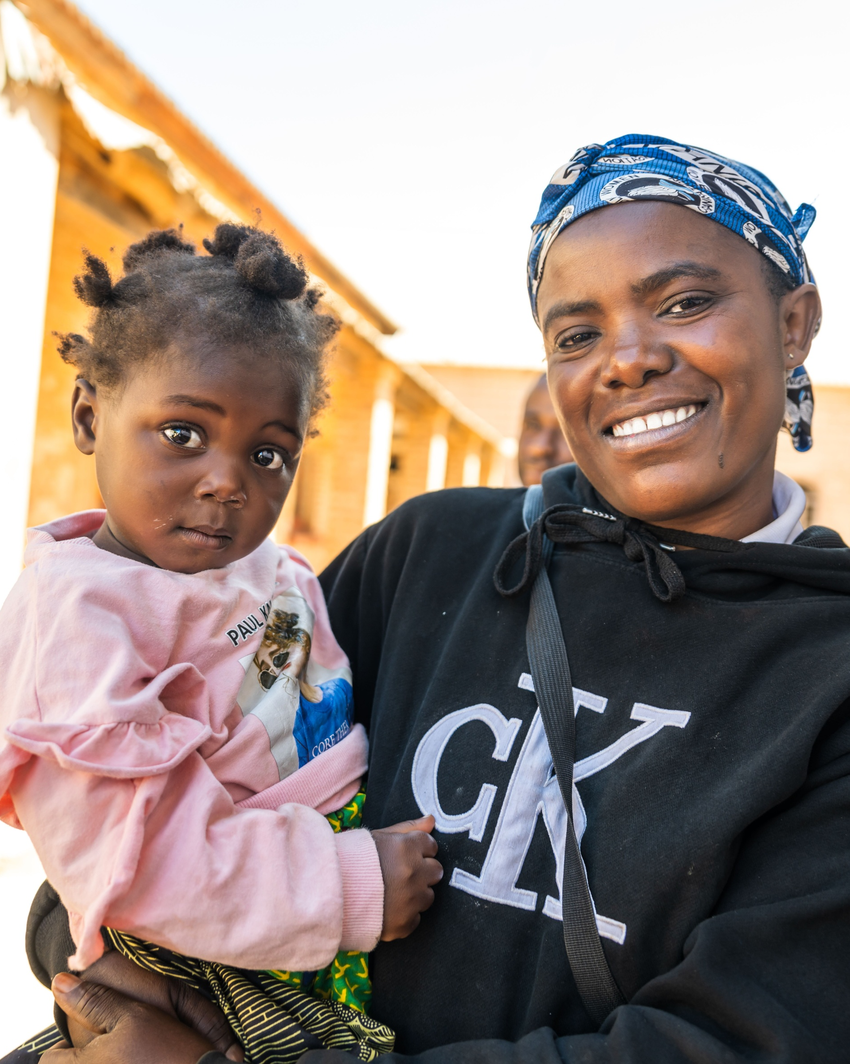
PRESIDER:
VENUE:
TIME:
Mission Mass 2025
Jubilee Year: Pilgrims of Hope
‘Missionaries of Hope Among All Peoples’.
PRESIDER:
VENUE:
TIME:
Missionaries of Hope Among All Peoples
Checklist of items and resources required for this Mass:
ITEMS
Clapping sticks
Coloured fabric (Zambian flag colours: green, red, black & orange) and boxes for a sacred space with book holders to support laminated photos
Image of Mpika Cathedral (pg. 3)
Basket of Maize (Corn)
Woven Sack or Fabric Sack
Sunflower
Image of Our Lady of Africa (pg. 4)
Photo of Zambian landscape (pg. 5)
Zambian Flag or image of flag (pg. 6)
A clear container of water
School candles or banners
Candle/s and lighter/match
Catholic Mission video (can be played at one of two times)
Catholic Mission PowerPoint resource
Computer

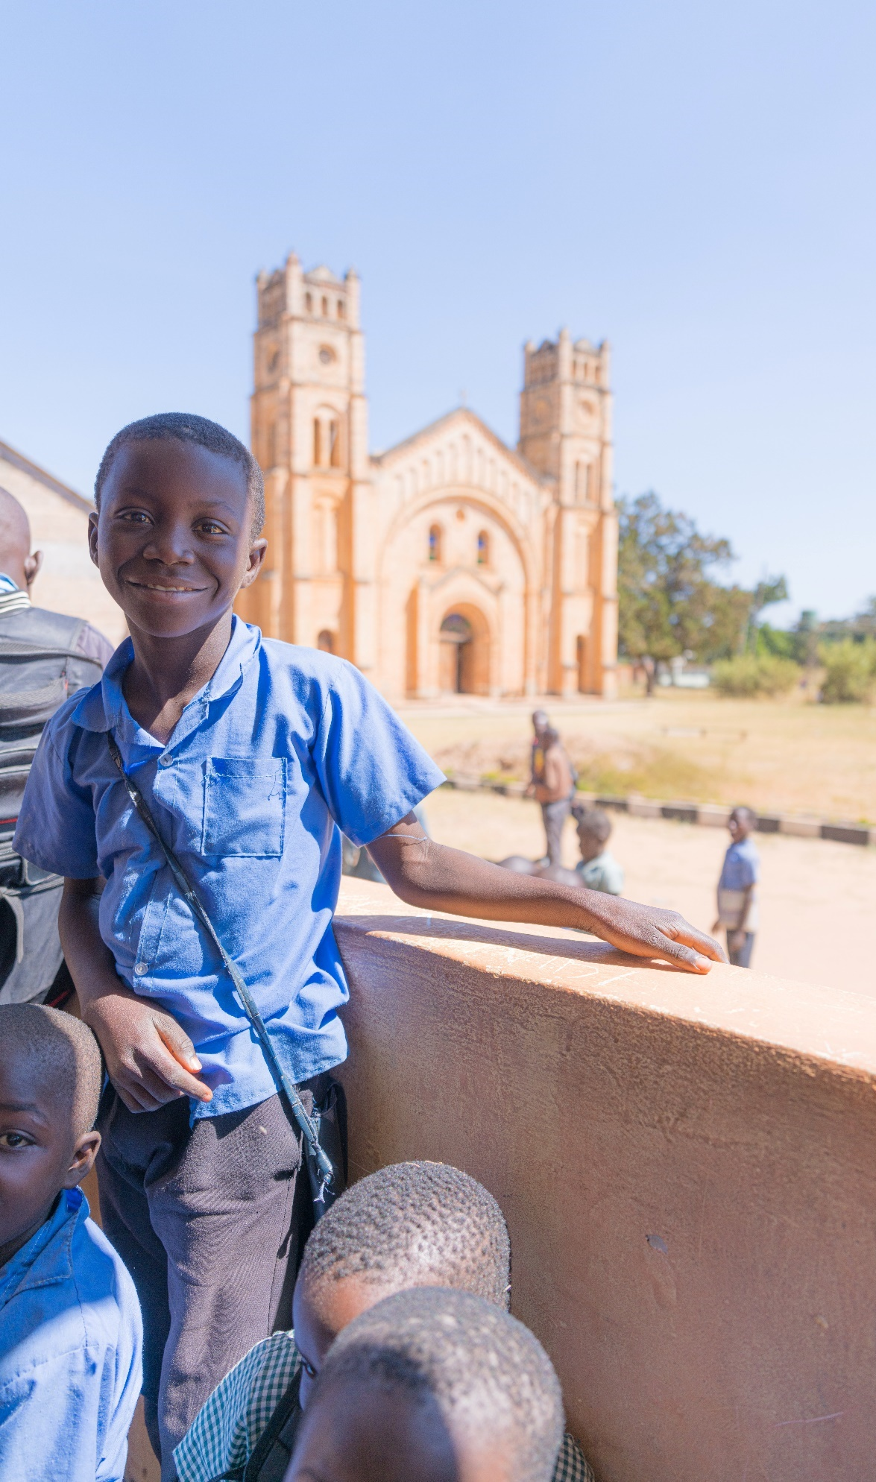

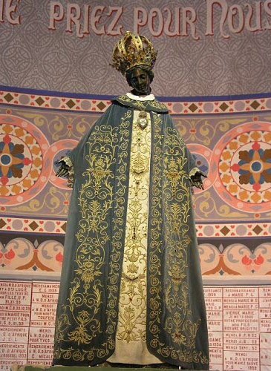

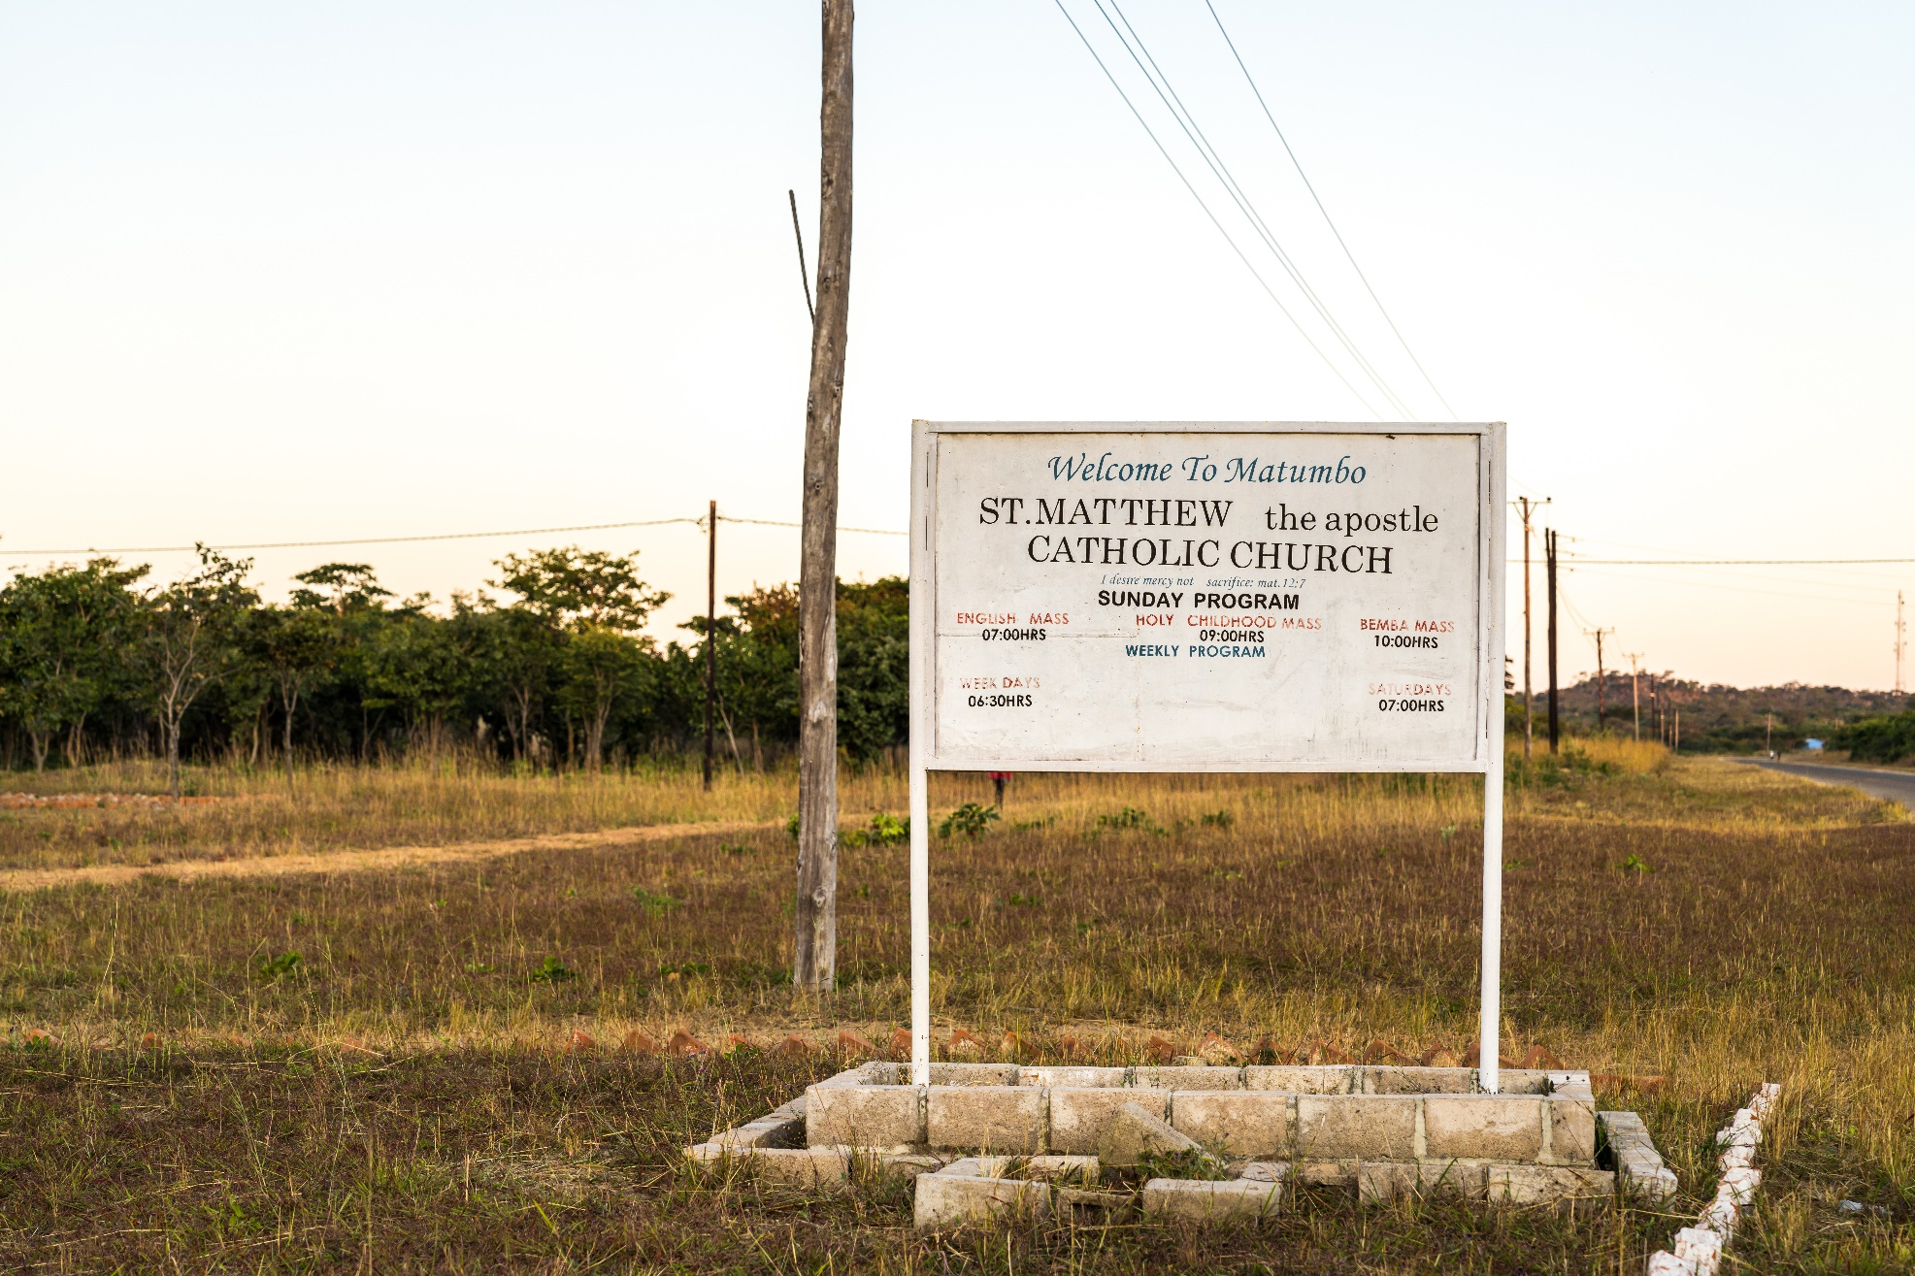
INTRODUCTION
Reflection
For us today: “Pilgrims of Hope” invites us to understand the struggles in our lives and the world - and to keep moving forward with hope. Hope isn’t about pretending everything is fine - it’s about choosing to believe that things can get better, even when they feel heavy through love of God. That our presence, our choices and our care can all make a difference.
This year, as we reflect on the people of Zambia, we get a real picture of what hope looks like in action. Life there isn’t always easy - many families face hard struggles like not having enough food, clean water, or access to education. But even in the middle of those struggles, the peoples are able to find strength, joy, and community.
Hope is the quiet strength that keeps us showing up, caring, and trusting that God walks with us. It calls us to listen, to learn from each other, and to value every person simply because they are human and apart of God’s creation. When we do this, we don’t walk ahead - we walk together, sharing stories, lifting each other up, and building a future that’s brighter because we know God walks with us.

Incorporating Zambia Culture:
In Zambia, clapping holds a deep cultural meaning; it is a gesture of respect, gratitude and apologies, it is integrated into much of their everyday greetings, celebrations and ceremonies. As we explore our focus country Zambia this World Mission Month, we are invited to weave elements of their rich into our liturgical celebrations.
Clapping three times is a traditional way of showing respect, especially during greetings, prayers, and ceremonies. It reflects attentiveness, appreciation, and unity among those gathered.
Here are some ways to incorporate this into your celebration:
- During the Eucharistic Prayer:
When the priest says, “It is right and just,” clap three times, once on each word:
Right 👏 and 👏 just 👏
- After the Sign of Peace:
Following the exchange of peace, invite the congregation to clap three times together as a sign of unity, joy, and mutual respect.
- During Hymns and Songs:
Clap along to the rhythm of the hymns throughout the Mass. Zambian liturgical celebrations are known for their lively music and spirited worship, and clapping is an important way the congregation joins in praise.

GATHERING
Acknowledgement of Country
— Student led
Introducing Zambia
Student: The wisdom and love of God is beyond our imagination. His goodness we treasure. He unfailingly lifts our minds to open up new and better means of sharing with each other, and hearing eachother stories. Today we will carry in our hearts, the stories, and peoples of Zambia.
Welcome to our liturgy for World Mission Month 2025: Our Catholic Mission theme this year: “Missionaries of Hope: Among All Peoples,” invites us to listen, learn, and be transformed.
Today we celebrate the people of Zambia, honouring the unique gifts they share with the world. With open hearts, we welcome the wisdom they offer, trusting that God inspires us to respond with compassion, justice and courageous action.
Let us create our sacred space.

Student: We will now create our sacred space for today’s liturgy, centred on Zambia, and more specifically, the Diocese of Mpika.
As we bring forward each item, we invite you to reflect on the faith, culture, and daily life of the people of Zambia. Through their stories, symbols, and strength, we are reminded of how God’s love is lived out across the world - especially in places that may seem far from our own.
Each item placed in the space represents a part of Zambia’s spirit- its faith, its people, its land, and its hope.
Student: We bring forward a picture of Mpika Cathedral. It’s a special church in the Diocese. It serves as a beacon of hope throughout the diocese, where many people come together to pray and is filled with love and hope. This reminds us that God is with us everywhere - even in faraway or quiet places.
The image is placed in the sacred space.
Student: We bring forward a basket of maize (we might know it as corn here in Australia) - a gift from the earth. In the Diocese of Mpika, maize is a daily food that comes from working closely with the land and with one another. It reminds us to always praise God for all of creation as God calls us to live with gratitude, simplicity, and care for our common home. The maize is placed in the sacred space.

Student: We bring forward a woven sack, a similar kind used to carry harvested maize in Zambia. It represents the hard work, resilience, and hope of the Zambian peoples - particularly the women who often carry heavy burdens yet continue to live with joy and generosity.
The sack is placed in the sacred space.
Student: In this Pilgrim Year of Hope and Jubilee, we bring forward a sunflower. In Zambia, sunflowers are grown for their oil and seeds, yet they also stand as a symbol of joy, light, and unwavering hope. Just as sunflowers turn toward the sun, may we too turn toward the light of Christ with open hearts and joyful trust.
The sunflower is placed in the sacred space.
Student: We bring forward an image of Our Lady of Africa, a beloved title for Mary cherished across Africa and around the world. In Zambia, as in our own communities, people turn to Mary in prayer, trusting in her loving presence as a caring mother who stays close in times of joy and in moments of struggle.
The image is placed in the sacred space.

Student: We bring forward a container of water, a precious resource across Zambia. Water is very important in Zambia because many people in Mpika get their water from wells, rivers, and rain. Water gives us life, cleans us, and helps us grow. It is a special gift from God that we must share and take care of.
The jug of water is placed in the sacred space.
Student: We bring forward the Zambian flag. Its green field represents Zambia’s lush landscape, the red stripe symbolises the nation's struggle for independence, the black symbolizes the unity and strength of the Zambian people and the orange for copper, the country’s mineral wealth. The eagle rising above reflects the Zambian spirit of hope and freedom.
The flag is placed in the sacred space.
Student: Students are now invited to place their school candles or banners around the sacred space. The candle reflects the light of Christ, present in all cultures and communities.
Candles and banners are placed in the space.

Student: May we open our hearts to learn more about the missionary work of the Church in Zambia, drawing inspiration from the remarkable creativity, resilience, and hope of the Zambian people. As we stand in solidarity with them in both their joys and their struggles, let us take a moment to reflect.
Student: We now invite you to watch a video prepared by Catholic Mission.
Play the Socktober 2025 video
Student: Please stand for our gathering song.

INTRODUCTORY RITES
Gathering Song Please stand.
Suggested for Primary Schools: Pilgrim of Hope - Andrew Chinn Suggested for High Schools: A Rightful Place - Steve Angrisano
[Please find the music resource files on ONELICENSE, find the relevant links on our webpage.]
Welcome
Presider: We gather as followers of Jesus, called in this Jubilee Year to be Pilgrims of Hope walking in solidarity with those who need our support the most.
We gather ... In the name of the Father, and of the Son, and of the Holy Spirit.
All: Amen.
Slight pause before proceeding.
Penitential Act
Presider: Brothers and sisters, let us acknowledge our sins and so prepare ourselves to celebrate the sacred mysteries.
You were sent to heal the contrite of heart. Lord, have mercy.

All: Lord, have mercy.
Presider: You came to call sinners. Christ, have mercy.
All: Christ, have mercy.
Presider: You are seated at the right hand of the Father to intercede for us. Lord, have mercy.
All: Lord, have mercy.
Slight pause.
Collect
Presider: Let us pray.
God of every nation,
You call us to be pilgrims of hope, journeying with courage and compassion.
Bless the people of Zambia, whose stories invite us to share, to listen, and to walk in solidarity.
May we live simply, love generously, and act justly - as missionaries of your Good News.
We ask this through Jesus Christ, your Son.
All: Amen.
Please be seated.

LITURGY OF THE WORD
Reading Isaiah 58:6–9a
Student:
A reading from the book of Isaiah

Is not this the fast that I choose:
to loose the bonds of injustice,
to undo the thongs of the yoke,
to let the oppressed go free,
and to break every yoke?
Is it not to share your bread with the hungry,
and bring the homeless poor into your house;
when you see the naked, to cover them,
and not to hide yourself from your own kin?
Then your light shall break forth like the dawn,
and your healing shall spring up quickly;
your vindicator shall go before you,
the glory of the Lord shall be your rear guard.
Then you shall call, and the Lord will answer,
you shall cry for help, and he will say, Here I am.
The Word of the Lord.
All: Thanks be to God.
Pause in silence for personal reflection on the reading.

Responsorial Psalm Psalm 85:10–13
Reader: The Lord hears the cry of the poor.
Response: The Lord hears the cry of the poor.
Reader: Steadfast love and faithfulness will meet;
righteousness and peace will kiss each other.
All: The Lord hears the cry of the poor.
Reader: Faithfulness will spring up from the ground,
and righteousness will look down from the sky.
All: The Lord hears the cry of the poor.
Reader: The Lord will give what is good,
and our land will yield its increase.
All: The Lord hears the cry of the poor.
Reader: Righteousness will go before him,
and will make a path for his steps.
All: The Lord hears the cry of the poor.
Pause in silence for personal reflection.
Gospel Acclamation Please stand.
Halle, Halle, Halle - Marty Haugen
[Please find the music resource files on GIA Music, find the relevant links on our webpage.]
Gospel Matthew 5:1–12 Please remain seated.
Presider: The Lord be with you.
All: And with your Spirit.
Presider: A reading from the Gospel according to Matthew
All: Glory to you O Lord
Presider:
When Jesus saw the crowds, he went up the mountain; and after he sat down, his disciples came to him.
Then he began to speak, and taught them, saying:
“Blessed are the poor in spirit, for theirs is the kingdom of heaven.
Blessed are those who mourn, for they will be comforted.
Blessed are the meek, for they will inherit the earth.
Blessed are those who hunger and thirst for righteousness, for they will be filled.
Blessed are the merciful, for they will receive mercy.
Blessed are the pure in heart, for they will see God.
Blessed are the peacemakers, for they will be called children of God.
Blessed are those who are persecuted for righteousness’ sake, for theirs is the kingdom of heaven.
Blessed are you when people revile you and persecute you and utter all kinds of evil against you falsely on my account.
Rejoice and be glad, for your reward is great in heaven, for in the same way they persecuted the prophets who were before you.”
The Gospel of the Lord
All: Praise to you, Lord Jesus Christ.
Homily
Prayers of intercession
Presider: Let us pray for the Church and for the world with hearts full of hope.
Student: For the Church in Zambia, that it may continue to be a light of hope and unity.
Lord hear us.
All: Lord, hear our prayer.
Student: For leaders around the world, that they govern with justice and mercy.
Lord hear us.
All: Lord, hear our prayer.
Student: For people who are poor, especially those in rural communities without food or water. May we respond in love.
Lord hear us.
All: Lord, hear our prayer.

Student: For all who work in mission - especially those walking alongside children and families in Zambia.
Lord hear us.
All: Lord, hear our prayer.
Student: Loving God, we pray for peace in our world. Guide our hearts to stand up against the injustices of the world. Strengthen us to stand in solidarity with all peoples experiencing injustices. Give us the courage to build your Kingdom, following in Christ’s footsteps to be the voice of people who aren’t being heard, acting when there is a need.
Lord hear us.
All: Lord, hear our prayer.
Student: For each of us, that we live simply, love deeply, and walk humbly with God as pilgrims of hope.
All: Lord, hear our prayer.
Staff: Loving God, we pray for First Nations peoples, the traditional custodians of this land, and thank them for caring for your precious creation. May we learn from their wisdom, working towards a sustainable future where the land is nurtured, respected, and shared by all.
Lord hear us.
All: Lord, hear our prayer.
Reflection song:
Suggested song: Ready the Way - Curtis Stephan
[Please find the music resource files on ONELICENSE, find the relevant links on our webpage.]
LITURGY OF THE EUCHARIST
Preparation of the Gifts
Please remain seated.
The gifts and bread and wine are brought forward.
Suggested song: Table Song - Kevin Bates
[Please find the music resource files on ONELICENSE, find the relevant links on our webpage.]
Presider: Blessed are you, Lord God of all creation, for through your goodness we have received the bread we offer you: fruit of the earth and work of human hands, it will become for us the bread of life.
All: Blessed be God forever
The Presider then places the paten with the bread on the corporal. The wine and a little water are poured into the chalice, saying quietly:
Presider: By the mystery of this water and wine may we come to share in the divinity of Christ who humbled himself to share in our humanity.

Taking the chalice and holding it slightly above the altar, Presider says inaudibly:
Presider: Blessed are you, Lord God of all creation, for through your goodness we have received the wine we offer you: fruit of the vine and work of human hands, it will become our spiritual drink.
All: Blessed be God forever
Then the Presider places the chalice on the corporal.
The Presider bows and says inaudibly:
Presider: With humble spirit and contrite heart may we be accepted by you, O Lord, and may our sacrifice in your sight this day be pleasing to you, Lord God.
The Presider washes his hands, saying inaudibly:
Presider: Wash me, O Lord, from my iniquity and cleanse me from my sin.
Prayer over the Offerings Please stand.
Presider: Pray, my brothers and sisters, that my sacrifice and yours may be acceptable to God, the almighty Father.
All: May the Lord accept the sacrifice at your hands for the praise and glory of his name, for our good and the good of all his holy Church.

Presider: Loving Creator look upon the face of your Christ, so that through him, from the rising of the sun to its setting, your name may be exalted among the nations, and in every place a single offering may be presented to you. Through Christ our Lord.
All: Amen.
Eucharistic Prayer for Children!
Presider: The Lord be with you.
All: And with your spirit.
Presider: Lift up your hearts.
All: We lift them up to the Lord.
Presider: Let us give thanks to the Lord our God.
All: It is right and just. (Clap three times)
The Presider, with hands extended, continues the Preface.
Presider: God our Father, you have brought us here together so that we can give you thanks and praise for all the wonderful things you have done. We thank you for all that is beautiful in the world and for the happiness you have given us. We praise you for daylight and for your word which lights up our minds. We praise you for the earth, and all the people who live on it, and for our life which comes from you. We know that you are good. You love us and do great things for us.
The Presider, with hands extended, says:
Loving God, you are always thinking about your people; you never forget us. You sent us your Son Jesus who gave his life for us and who came to save us. He cured sick people; He cared for those who were poor and wept for those who were sad. He forgave sinners and taught us to forgive each other. He loved everyone and showed us how to be kind. He took children in his arms and blessed them.
The Presider, with hands extended, continues:
Creator God, all over the world your people praise you.
So now we pray with the whole Church: with Leo our Pope and me, your unworthy servant. In heaven the blessed Virgin Mary, the Apostles and all the Saints always sing your praise. Now we join with them and with the Angels to adore you as we sing:
All: Holy, Holy, Holy Lord, God of hosts. Heaven and earth are full, full of your glory. Hosanna in the highest. Blessed is he who comes in the name of the Lord Hosanna in the highest.
The Presider, with hands extended, continues:
Presider: God our Father, you are most holy, and we want to show you that we are grateful. We bring you bread and wine

The Presider joins his hands and, holding them extended over the offerings, says:
Presider: And ask you to send your Holy Spirit to make these gifts
He joins hands and makes the Sign of the Cross once over the bread and chalice together, saying:
Presider: The body ✠ and blood of Jesus your Son.
The Presider joins his hands.
Presider: Then we can offer to you what you have given for us. On the night before he died, Jesus was having supper with his Apostles.
The Presider takes the bread and, holding it slightly raised above the altar, continues:
Presider: He took bread from the table.
He gave you thanks and praise.
Then he broke the bread, gave it to his friends and said:
He bows slightly.
Presider: Take this, all of you and eat of it:
for this is my body
which will be given up for you.
The Presider shows the consecrated host to the people, places it again on the paten, and genuflects in adoration.
After this, he continues:
Presider: When supper was ended,
The Presider takes the chalice and, holding it slightly raised above the altar, continues:
Presider: Jesus took the cup that was filled with wine. He thanked you, gave it to his friends and said: take this, all of you, and drink from it: this is the cup of my blood, the blood of the new and eternal covenant, which will be poured out for you and for many for the forgiveness of sins. Then he said to them: do this in memory of me.
He shows the chalice to the people, places it on the corporal, and genuflects in adoration.
Then, with hands extended, the Presider says:
Presider: We do now what Jesus told us to do. We remember his death and his resurrection, and we offer you, loving God, the bread that gives us life, and the cup that saves us. Jesus brings us to you; Welcome us as you welcome him. Let us proclaim our faith:
All: When we eat this bread and drink this cup
We proclaim your death O Lord,
Until you come again.

Then the Presider, with hands extended, says:
Presider: Father, because you love us, you invite us to come to your table. Fill us with the joy of the Holy Spirit as we receive the body and blood of your Son.
Lord, you never forget any of your children. We ask you to take care of those we love, and we pray for those who have died.
Remember everyone who is suffering from
pain or sorrow. Remember Christians everywhere and all other people in the world. We are filled with wonder and praise when we see what you do for us through Jesus your Son, and so we give you praise.
Through him, and with him, and in him, O God almighty Father, in the unity of the Holy Spirit, all glory and honour is yours, almighty Father, forever, and ever.
All: Amen
Communion Rite
Presider: At the Saviour’s command and formed by divine teaching, we dare to say:
All: Our Father, who art in heaven, hallowed be thy name; thy kingdom come, thy will be done on earth as it is in heaven. Give us this day our daily bread, and forgive us our trespasses, as we forgive those who trespass against us; and lead us not into temptation but deliver us from evil.
Presider: Deliver us, Lord, we pray, from every evil, graciously grant peace in our days, that, by the help of your mercy, we may be always free from sin and safe from all distress, as we await the blessed hope and the coming of our Saviour, Jesus Christ.
The Presider joins his hands, and the people conclude the prayer, saying:
All: For the kingdom, the power and the glory are yours now and for ever.
Presider: Lord Jesus Christ, who said to your Apostles: Peace, I leave you, my peace I give you, look not on our sins, but on the faith of your Church, and graciously grant her peace and unity in accordance with your will. Who live and reign for ever and ever.
All: Amen.
The Presider extends and then joins his hands, and continues:
Presider: The peace of the Lord be with you always.
All: And with your spirit.
Presider: Let us offer each other the sign of peace.
The assembly exchanges a sign of peace. The Presider then takes the host, breaks it over the paten, and places a small piece in the chalice, saying quietly:

Presider: May this mingling of the Body and Blood of our Lord Jesus Christ bring eternal life to us who receive it.
All: Lamb of God, you take away the sins of the world, have mercy on us.
Lamb of God, you take away the sins of the world,
have mercy on us.
Lamb of God, you take away the sins of the world,
grant us peace.
The Presider, with hands joined, continues inaudibly:
Presider: May the receiving of your Body and Blood, Lord Jesus Christ, not bring me to judgement and condemnation, but through your loving mercy be for me protection in mind and body and a healing remedy.
The Presider genuflects, takes the host and, holding it slightly raised above the paten or above the chalice, while facing the people, says aloud:
Presider: Behold the Lamb of God, behold him who takes away the sins of the world. Blessed are those called to the supper of the Lamb.
All: Lord, I am not worthy that you should enter under my roof but only say the word and my soul shall be healed.
The Presider, facing the altar, says quietly:
Presider: May the Body of Christ keep me safe for eternal life.
And he reverently consumes the Body of Christ. Then he takes the chalice and says quietly:
Presider: May the Blood of Christ keep me safe for eternal life.
And he reverently consumes the Blood of Christ.
The Communion hymn begins as the Presider receives the Body of Christ and continues as needed for the duration of the Communion Procession.
Communion song:
Suggested song: Bigger Table - Matt Maher
[Please find the song using the relevant links on our webpage.]
Prayer after Communion Please stand.
Presider: Let us pray
Pause for silent prayer
All: Amen.

CONCLUDING RITES
Greeting
Presider: The Lord be with you.
All: And with your spirit.
Solemn Blessing
Presider: In Christ, God has revealed his love and his truth.
May he make you witnesses to the Gospel and to the divine love.
All: Amen.
Presider: The Lord Jesus promised to be with his Church until the end of the world. May he give power to your actions and your words.
All: Amen.
Presider: May the Spirit of the Lord be with you, so that you may go through the world to bring the Good News.
All: Amen.
Presider: May almighty God bless you, the Father, and the Son, and the Holy Spirit.
All: Amen.

DISMISSAL
Presider: O God, you send us out as messengers of joy, peace, and justice. May your Spirit guide our every step.
As missionaries of hope, may we lift each other up, care for creation, and bring your love to the world.
May almighty God bless you, the Father, and the Son, and the Holy Spirit. Let us go in peace to love and serve God and one another.
All: Amen
Recessional song:
Suggested for Primary Schools: Hearts on Fire- Michael Mangan
Suggested for High Schools: Go out, Go Out - Curtis Stephan
[Please find the music resource files on our webpage.]

Acknowledgements
Reading and Gospel from New Revised Standard Version Bible: Catholic Edition, copyright © 1989, 1993 the Division of Christian Education of the National Council of the Churches of Christ in the United States of America. All rights reserved.
Text Excerpts from the English translation of The Roman Missal © 2010, International Commission on English in the Liturgy Corporation. All rights reserved.
Images and Symbols:
P.1: Photograph by Simone Medri. © Catholic Mission 2025
P.3: Photograph by Simone Medri. © Catholic Mission 2025
P.4: Le Progres Newspaper
P.5: Photograph by Simone Medri. © Catholic Mission 2025
P.6: FOTW Flags Of The World website

