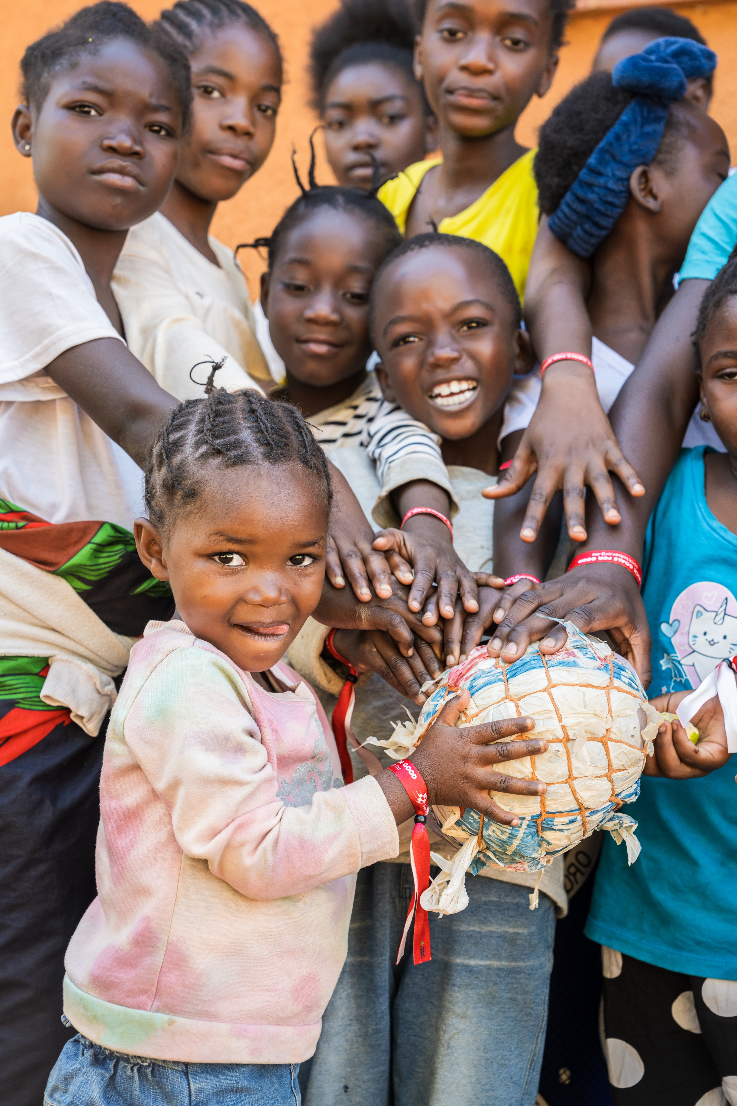
Mission Liturgy 2025
Jubilee Year: Pilgrims of Hope
‘Missionaries of Hope Among All Peoples’.

PRESIDER:
VENUE:
TIME:
Missionaries of Hope Among All Peoples
Checklist of items and resources required for this Mass:
ITEMS
Clapping sticks
Coloured fabric (Zambian flag colours: green, red, black & orange) and boxes for a sacred space with book holders to support laminated photos
Image of Mpika Cathedral (pg. 3)
Basket of Maize (Corn)
Woven Sack or Fabric Sack
Sunflower
Image of Our Lady of Africa (pg. 4)
Photo of Zambian landscape (pg. 5)
Zambian Flag or image of flag (pg. 6)
A clear container of water
School candles or banners
Candle/s and lighter/match
Catholic Mission video (can be played at one of two times)
Catholic Mission PowerPoint resource
Computer

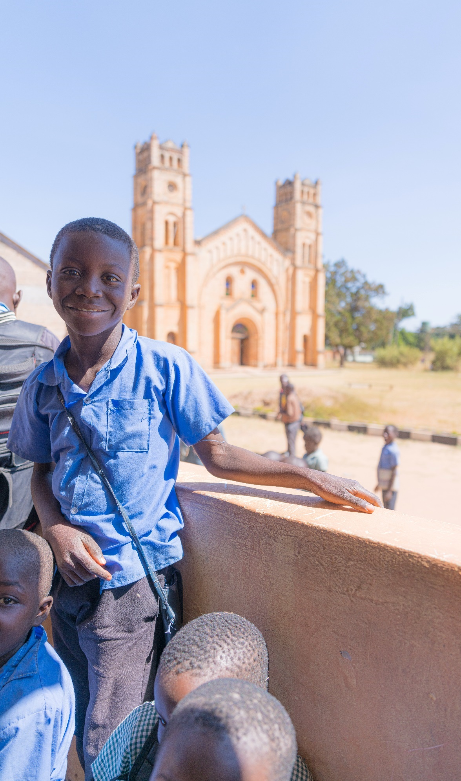

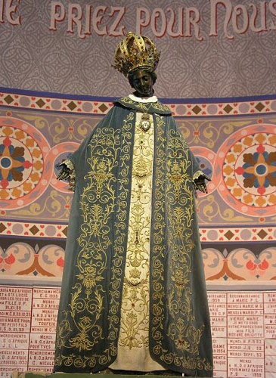

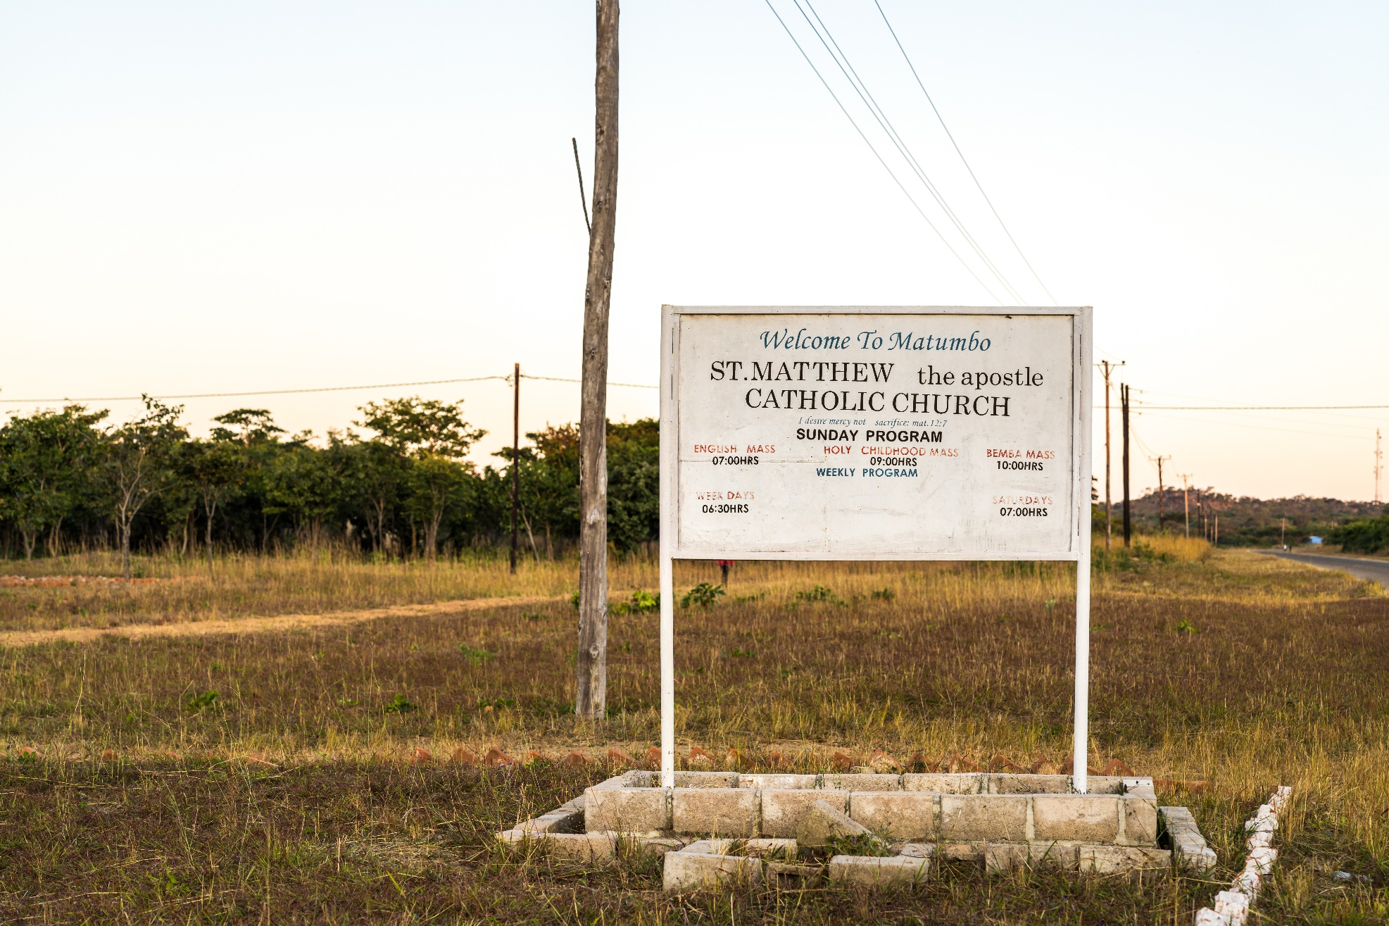
INTRODUCTION
Reflection
For us today: “Pilgrims of Hope” invites us to understand the struggles in our lives and the world - and to keep moving forward with hope. Hope isn’t about pretending everything is fine - it’s about choosing to believe that things can get better, even when they feel heavy through love of God. That our presence, our choices and our care can all make a difference.
This year, as we reflect on the people of Zambia, we get a real picture of what hope looks like in action. Life there isn’t always easy - many families face hard struggles like not having enough food, clean water, or access to education. But even in the middle of those struggles, the peoples are able to find strength, joy, and community.
Hope is the quiet strength that keeps us showing up, caring, and trusting that God walks with us. It calls us to listen, to learn from each other, and to value every person simply because they are human and apart of God’s creation. When we do this, we don’t walk ahead - we walk together, sharing stories, lifting each other up, and building a future that’s brighter because we know God walks with us.

GATHERING
Acknowledgement of Country
— Student Led
Introducing Zambia
Student: The wisdom and love of God is beyond our imagination. His goodness we treasure. He unfailingly lifts our minds to open up new and better means of sharing with each other, and hearing each other stories. Today we will carry in our hearts, the stories, and peoples of Zambia.
Welcome to our liturgy for World Mission Month 2025: Our Catholic Mission theme this year: “Missionaries of Hope: Among All Peoples,” invites us to listen, learn, and be transformed.
Today we celebrate the people of Zambia, honouring the unique gifts they share with the world. With open hearts, we welcome the wisdom they offer, trusting that God inspires us to respond with compassion, justice and courageous action.
Let us create our sacred space.

Student: We will now create our space for today’s liturgy, centred on Zambia, and more specifically, the Diocese of Mpika.
As we bring forward each item, we invite you to reflect on the faith, culture, and daily life of the people of Zambia. Through their stories, symbols, and strength, we are reminded of how God’s love is lived out across the world - especially in places that may seem far from our own.
Each item placed in the space represents a part of Zambia’s spirit- its faith, its people, its land, and its hope.
Student: We bring forward a picture of Mpika Cathedral. It’s a special church in the Diocese. It serves as a beacon of hope throughout the diocese, where many people come together to pray and is filled with love and hope. This reminds us that God is with us everywhere - even in faraway or quiet places.
The image is placed in the sacred space.
Student: We bring forward a basket of maize (we might know it as corn here in Australia) - a gift from the earth. In the Diocese of Mpika, maize is a daily food that comes from working closely with the land and with one another. It reminds us to always praise God for all of creation as God calls us to live with gratitude, simplicity, and care for our common home.
The maize is placed in the sacred space.
Student: We bring forward a woven sack, a similar kind used to carry harvested maize in Zambia. It represents the hard work, resilience, and hope of the Zambian peoples - particularly the women who often carry heavy burdens yet continue to live with joy and generosity.
The sack is placed in the sacred space.
Student: In this Pilgrim Year of Hope and Jubilee, we bring forward a sunflower. In Zambia, sunflowers are grown for their oil and seeds, yet they also stand as a symbol of joy, light, and unwavering hope. Just as sunflowers turn toward the sun, may we too turn toward the light of Christ with open hearts and joyful trust.
The sunflower is placed in the sacred space.
Student: We bring forward an image of Our Lady of Africa, a beloved title for Mary cherished across Africa and around the world. In Zambia, as in our own communities, people turn to Mary in prayer, trusting in her loving presence as a caring mother who stays close in times of joy and in moments of struggle.
The image is placed in the sacred space.

Student: We bring forward a container of water, a precious resource across Zambia. Water is very important in Zambia because many people in Mpika get their water from wells, rivers, and rain. Water gives us life, cleans us, and helps us grow. It is a special gift from God that we must share and take care of.
The jug of water is placed in the sacred space.
Student: We bring forward the Zambian flag. Its green field represents Zambia’s lush landscape, the red stripe symbolises the nation's struggle for independence, the black symbolizes the unity and strength of the Zambian people and the orange for copper, the country’s mineral wealth. The eagle rising above reflects the Zambian spirit of hope and freedom.
The flag is placed in the sacred space.
Student: Students are now invited to place their school candles or banners around the sacred space. The candle reflects the light of Christ, present in all cultures and communities.
Candles and banners are placed in the space.

Student: May we open our hearts to learn more about the missionary work of the Church in Zambia, drawing inspiration from the remarkable creativity, resilience, and hope of the Zambian people. As we stand in solidarity with them in both their joys and their struggles, let us take a moment to reflect.
Student: We now invite you to watch a video prepared by Catholic Mission.
Play the Socktober 2025 video
Student: Please stand for our gathering song.

INTRODUCTORY RITES
Gathering Song Please stand.
Suggested for Primary Schools: Pilgrim of Hope- Andrew Chin
Suggested for High Schools: A Rightful Place - Steve Angrisano
[Please find the music resource files on ONELICENSE, find the relevant links on our webpage.]
Welcome
Presider: We gather as followers of Jesus, called in this Jubilee Year to be Pilgrims of Hope walking in solidarity with those who need our support the most.
We gather ... In the name of the Father, and of the Son, and of the Holy Spirit.
All: Amen.
Slight pause before proceeding.
Presider: Lord Jesus, you walk with all of creation, especially people who are living on the margins.
Lord, have mercy.
All: Lord, have mercy.
Presider: You lift up the people who are poor and forgotten.

Christ, have mercy.
All: Christ, have mercy.
Presider: You call us to be bearers of hope.
Lord, have mercy.
All: Lord, have mercy.
Presider: May loving God, who is rich in mercy, forgive us, renew our hearts, and lead us to everlasting peace.
All: Amen.
Opening Prayer
Presider: Let us pray.
God of every nation,
You call us to be pilgrims of hope, journeying with courage and compassion.
Bless the people of Zambia, whose stories invite us to share, to listen, and to walk in solidarity.
May we live simply, love generously, and act justly - as missionaries of your Good News.
We ask this through Jesus Christ, your Son.
All: Amen.
Please be seated.

LITURGY OF THE WORD
Reading Isaiah 58:6–9a
Student:
A reading from the book of Isaiah
Is not this the fast that I choose:
to loose the bonds of injustice,
to undo the thongs of the yoke,
to let the oppressed go free,
and to break every yoke?
Is it not to share your bread with the hungry,
and bring the homeless poor into your house;
when you see the naked, to cover them,
and not to hide yourself from your own kin?
Then your light shall break forth like the dawn,
and your healing shall spring up quickly;
your vindicator shall go before you,
the glory of the Lord shall be your rear guard.
Then you shall call, and the Lord will answer,
you shall cry for help, and he will say, Here I am.
The Word of the Lord.
All: Thanks be to God.
Pause in silence for personal reflection on the reading.

Responsorial Psalm Psalm 85:10–13
Reader: The Lord hears the cry of the poor.
Response: The Lord hears the cry of the poor.
Reader: Steadfast love and faithfulness will meet;
righteousness and peace will kiss each other.
All: The Lord hears the cry of the poor.
Reader: Faithfulness will spring up from the ground,
and righteousness will look down from the sky.
All: The Lord hears the cry of the poor.
Reader: The Lord will give what is good,
and our land will yield its increase.
All: The Lord hears the cry of the poor.
Reader: Righteousness will go before him,
and will make a path for his steps.
All: The Lord hears the cry of the poor.
Pause in silence for personal reflection.
Gospel Acclamation
Halle, Halle, Halle - Marty Haugen
[Please find the music resource files on GIA Music, find the relevant links on our webpage.]

Gospel Matthew 5:1–12 Please remain seated.
Presider: The Lord be with you.
All: And with your Spirit.
Presider: A reading from the Gospel according to Matthew
All: Glory to you O Lord
Presider:
When Jesus saw the crowds, he went up the mountain; and after he sat down, his disciples came to him.
Then he began to speak, and taught them, saying:
“Blessed are the poor in spirit, for theirs is the kingdom of heaven.
Blessed are those who mourn, for they will be comforted.
Blessed are the meek, for they will inherit the earth.
Blessed are those who hunger and thirst for righteousness, for they will be filled.
Blessed are the merciful, for they will receive mercy.
Blessed are the pure in heart, for they will see God.
Blessed are the peacemakers, for they will be called children of God.
Blessed are those who are persecuted for righteousness’ sake, for theirs is the kingdom of heaven.
Blessed are you when people revile you and persecute you and utter all kinds of evil against you falsely on my account.
Rejoice and be glad, for your reward is great in heaven, for in the same way they persecuted the prophets who were before you.”
The Gospel of the Lord
All: Praise to you, Lord Jesus Christ.
Student Reflection of Gospel
Reflection Song:
Thy word - Amy Grant
[Please find the music resource files on ONELICENSE, find the relevant links on our webpage.]
Student: In today’s Gospel, we hear what it means to be truly blessed. It’s not about being popular or successful, but about being humble, peaceful, and compassionate - even when it’s hard. Jesus reminds us that God is especially close to those who are hurting, left out, or standing up for what’s right. This is the kind of hope that doesn’t give up -the kind that can change lives. It’s the same hope we see in the people of Zambia: in their care for one another, their deep faith, and their joy, even in struggle.
Sing: Thy word is a lamp unto my feet and a light unto my path.
Student: This Psalm reminds us that when love, justice, and peace come together, God is near. It speaks of a world where things grow, where the earth gives back, and where goodness leads the way. That’s the kind of world we hope for - and the kind we’re invited to help build. In Zambia, even when life is difficult, people plant seeds - not just in the ground, but in the way they treat one another. And when we listen to their stories, and walk with them, we help make that path of justice and peace stronger for everyone.
Sing: Thy word is a lamp unto my feet and a light unto my path.
Student: In the Gospel reading from Matthew - The Beatitudes show us a different way to live - one that puts others first and trusts that God is always with us, especially when things are tough. When Jesus says, “Blessed are the poor in spirit,” he’s not necessarily talking about having nothing - he’s talking about needing God and relying on love more than power. That’s the heart of mission too. In Zambia, people rely on each other, on their communities, and on God. Their hope doesn’t have to be loud, but it’s real. And we’re called to share in it - to walk with them, not ahead of them. To be pilgrims of hope, together.
Sing: Thy word is a lamp unto my feet and a light unto my path.

Prayers of intercession
Presider: Let us pray for the Church and for the world with hearts full of hope.
Student: For the Church in Zambia, that it may continue to be a light of hope and unity.
Lord hear us.
All: Lord, hear our prayer.
Student: For leaders around the world, that they govern with justice and mercy.
Lord hear us.
All: Lord, hear our prayer.
Student: For people who are poor, especially those in rural communities without food or water. May we respond in love.
Lord hear us.
All: Lord, hear our prayer.
Student: For all who work in mission - especially those walking alongside children and families in Zambia.
Lord hear us.
All: Lord, hear our prayer.

Student: Loving God, we pray for peace in our world. Guide our hearts to stand up against the injustices of the world. Strengthen us to stand in solidarity with all peoples experiencing injustices. Give us the courage to build your kingdom, following in Christ’s footsteps to be the voice of people who arent’ being heard, acting when there is a need.
Lord hear us.
All: Lord, hear our prayer.
Student: For each of us, that we live simply, love deeply, and walk humbly with God as pilgrims of hope.
All: Lord, hear our prayer.
Staff: Loving God, we pray for First Nations peoples, the traditional custodians of this land, and thank them for caring for your precious creation. May we learn from their wisdom, working towards a sustainable future where the land is nurtured, respected, and shared by all.
Lord hear us.
All: Lord, hear our prayer.
Reflection song:
Ready the Way - Curtis Stephan
[Please find the music resource files on ONELICENSE, find the relevant links on our webpage.]
The Our Father
Presider: Please join us in saying the prayer Jesus has taught us.
All: Our Father, who art in heaven, hallowed be thy name; thy kingdom come, thy will be done on earth as it is in heaven. Give us this day our daily bread, and forgive us our trespasses, as we forgive those who trespass against us; and lead us not into temptation but deliver us from evil.
Amen

CONCLUDING RITE
Greeting
Presider: O God, you send us out as messengers of joy, peace, and justice.
May your Spirit guide our every step.
As missionaries of hope, may we lift each other up, care for creation, and bring your love to the world.
May almighty God bless you, the Father, and the Son, and the Holy Spirit. Let us go in peace to love and serve God and one another.
All: Amen
Recessional song:
Suggested for Primary Schools: Hearts on Fire- Michael Mangan
Suggested for High Schools: Go out, Go Out - Curtis Stephan
[Please find the music resource files on our webpage.]

Acknowledgements
Reading and Gospel from New Revised Standard Version Bible: Catholic Edition, copyright © 1989, 1993 the Division of Christian Education of the National Council of the Churches of Christ in the United States of America. All rights reserved.
Text Excerpts from the English translation of The Roman Missal © 2010, International Commission on English in the Liturgy Corporation. All rights reserved.
Images and Symbols:
P.1: Photograph by Simone Medri. © Catholic Mission 2025
P.3: Photograph by Simone Medri. © Catholic Mission 2025
P.4: Le Progres Newspaper
P.5: Photograph by Simone Medri. © Catholic Mission 2025
P.6: FOTW Flags Of The World website

